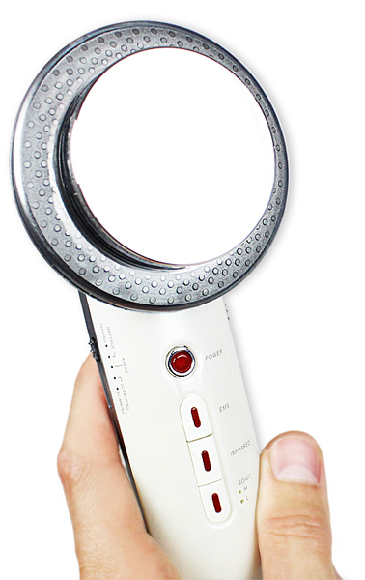
Ultrasound cavitation system 3in1
User Guide
Contents:
3
3
4
4
4
5
6
6
6
7
9
10
10
10
11
14
15
15
Main sense of use……………………………………………………………………
Warning………………………………………………………………………………………
Contraindication…………………………………………………………………………………
Body parts which must not be treated……………………………………………
Body parts which is possible to treat + recommended treatment time…
Performance devices and specifications technology……………………………
Features and specifications………………………………………………………….…
Technical parameters………………………………………………………………………
Device and device parts description……………………………………………
Ultrasound cavitation function - application process……………………..
Infrared light function - application process………………………………………
Electrostimulator - application process……………………………………………
Dangerous………………………………………………………………………………………
Warning…………………………………………………………………………………………
Notice...………………………………………………………………………………………
F.A.Q. [cavitation] ………..........................……………………………………
Certification………………………………………………………………………………………
Importer………………………………………………………………………………….………

Dear customer,

thanks a lot for purchasing of our product. Before first use please read all information in this manual carefully. Pay attention about the safety notices. Use the device according to the instructions. All these steps will lead to maximum use of all functions of the device.

Instructions for use should be retained for future reference.
Main sense of use

The device has technologies which have scientific knowledge by the positive influence on the reduction of surplus fat layers and the overall hardening character. All the technologies used are non-invasive. The device is intended solely for aesthetic purposes. In any case the device is not used for medical treatment.
Warning


- Before first use, carefully read the instruction manual
- All cables and accessories must be connected exactly as described in this manual
- Do not use in places where the presence of oils, smoke, dust, dirt, or where it may come in contact with water
- Adhere strictly to the length and manner of treatment
- Do not mix device using the apparatus of another manufacturer
- If you feel during use, although abnormally, switch off the device and its use consult your doctor
- After use always unplug the power cord
- If the device is not in use, do not leave it plugged in
- Do not bend the power cord; Do not place sharp, heavy or wet objects
- Before plugging always check that the electrical system corresponds to the desired voltage
- During operation to avoid similar items, such as candles, cigarettes, spirits
- If the device will have any technical problems, contact your dealer
- Use of the device is not suitable for:
• persons suffering from epilepsy
• persons with high fever
• pregnant women
• people who are suffering in places designated for application instrument skin disease
• persons suffering from fatigue syndrome
• persons who require constant supervision, the unit may only be used after prior consultation with a doctor
- Do not attempt to disassemble or repair - you could get injured and would void the warranty
- If any of these situations, the unit never use:
• the power cord is damaged
• spilled into water
• device to a heavy object fell or dropped from a great height onto the ground
- The unit must in no case be used by pregnant women or people with pacemakers
- Avoid using the machine if you are ill
- The device is powered exclusively by an electric cable, which is included
(Another type of cable is prohibited)
- Do not use the device in close proximity to other electrical equipment
- Make sure that the device and all of its components are always dry
- Flat applicator head after each use, clean with a soft wet a sponge in alcohol solution and the other a sponge dry dry
- Never pull the power cord out of the socket so that is ripping the hand pulling the cord, always use the grip to pull the plug

Contraindication

The device may in no case be used by people who suffer from any of these conditions:

• cancer, epilepsy, diabetes
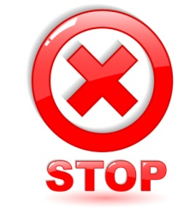
• Serious kidney or liver disease
• High Cholesterol
• Skin diseases
• Heart disease, pacemaker, hypertension
• Metal implants in the body
• Vascular disorders or arteoskleróza
• Pregnancy
• Menstruation
• Persons using medication to thin the blood
• Patients who underwent operative intervention with transplantation
Body parts which must not be treated

• head (excluding the area under the chin)
• area where the heart is
• armpits
• palms
• foot
• elbow area
• spine

Body parts which is possible to treat + recommended treatment time
Body parts Recommended treatment time

- jowls 5 minutes
- decollete 10 minut !! Avoid areas where the heart is!!
- hips 20 minutes
- thighs 20 minutes
- Arm 20 minutes
- Abdomen 20 minutes
- Calf 20 minutes

You can treat a maximum two body parts together . Further treatment may be carried out for 7-10 days. Note: chin area can be treated only if the user does not mouth any metal implants, dentures or any foreign objects.
Performance devices and specifications technology

Ultrasound cavitation system 3in1 is a certified revolutionary apparatus, which you in the comfort of your home as your figure in a beauty studio! With a combination of three functions you get a powerful tool in the fight against surplus fat, cellulite and sagging skin. For treatments in salons pay tens of thousands. Now a fraction of the cost capture technology used by professionals!

Ultrasound cavitation
Apparatus for home cavitation generated through large applicator head ultrasound waves that penetrate the skin. Tissues then absorb this ultrasonic energy. The disruption of the integrity of the fat cells and the fat is released. Released fat is cleaved to glycerol and free fatty acids. Glycerol serves as an energy source, while the fatty acids are transferred into the liver, where they are treated as normal fatty acids from food and excreted from the body naturally. The removed fat tissue back into refunded. Ultrasonic cavitation is a painless, non-invasive, gentle, effective and most permanent method for removing fatty tissue, cellulite reduction and skin smoothing.

Infrared light therapy
Along the perimeter of the applicator head units are built in 4 IR emitters. Infrared rays penetrate into the body in the wavelength range of 8 to 12nm. The infrared radiation in comparison to other sources of heat better ability to penetrate deeper into the subcutaneous tissue. Infrared heat is strongly supported by circulation. The body is then able to quickly get rid of harmful substances and waste products. Contributes to the overall regeneration and recovery of the body.

Electrostimulator (EMS)
Home cavitation also has a electrostimulator function. The basis of the movement of the body's muscle contractions that receive commands through the business impulses transmitted from the brain. The movement of the muscles naturally strengthens. Muscles work just on those parts where gel electrode stick. You can easily adjust the strength of pulses, which are transmitted through the skin electrodes to the muscles. Stronger impulses for actively strengthening muscles. Finer contrary to their release after physical exertion. You can use the application, two electrodes simultaneously.

Features and Specifications
• certified device
• absolutely safe treatment
• easy to use, easy to operate
• treatments in the comfort of home
• english instruction manual covers in detail all instructions
• technologies: ultrasound cavitation, infrared light therapy, electrical muscle stimulation

Technical specification

• European certification: Yes
• Dimensions: 18,7x8x6cm
• Weight: 240 grams
• Power: DC15V adapter from 220V
• Contents: device on the home cavitation 3v1 power adapter, 2 gel electrodes, instruction manual

Device and device parts description

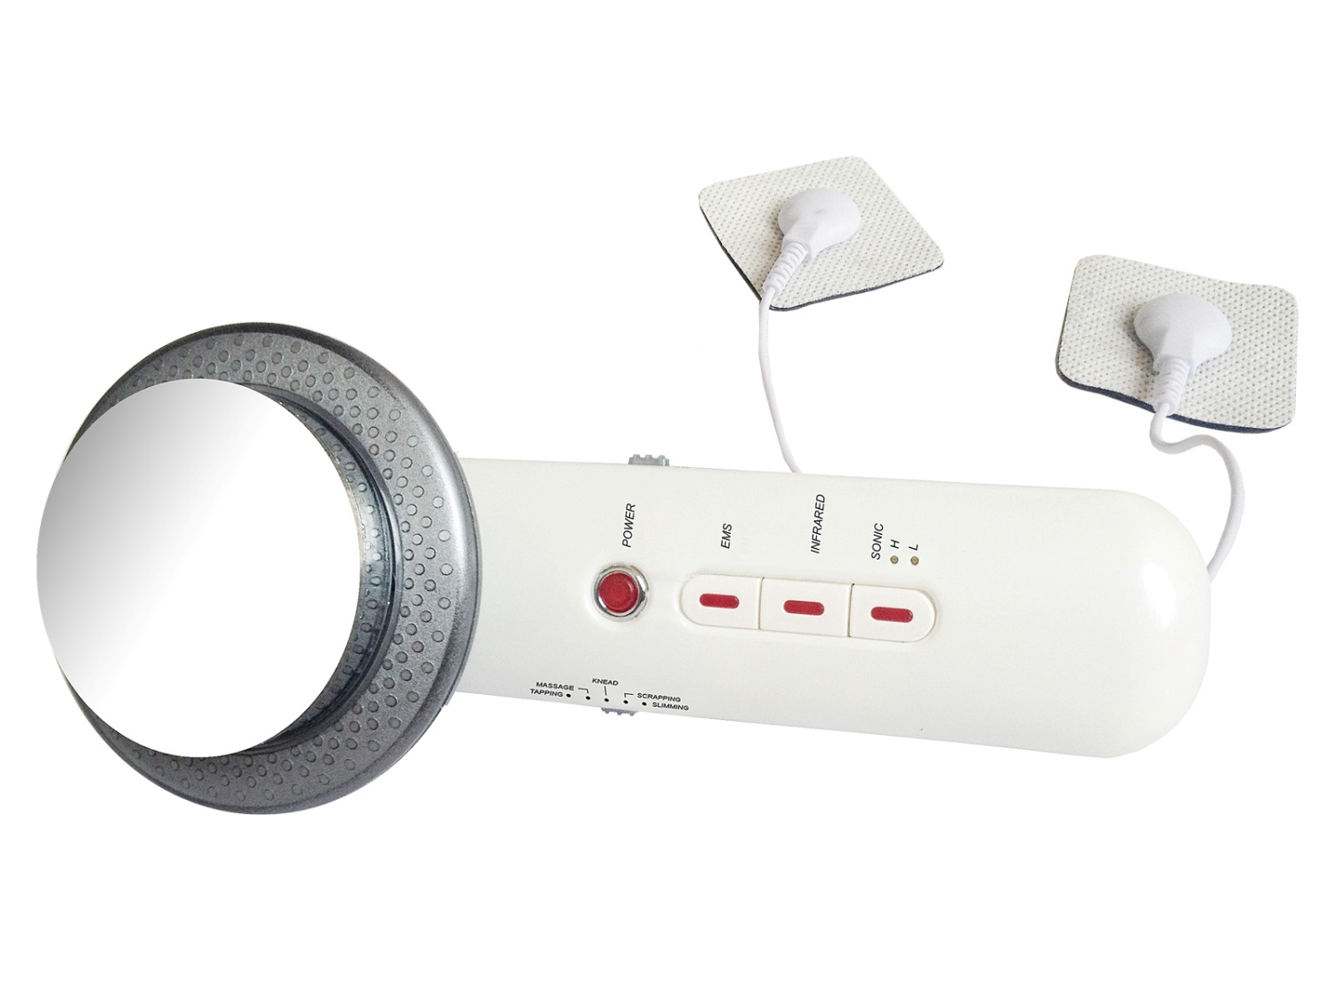
application head of the ultrasound cavitation
application gel electrodes for electrostimulator

electrostimulator function adjust
elektro pulse
level setup
ultrasound wave
level adjust
infrared therapy
on/off button
electrostimulator
on/off button

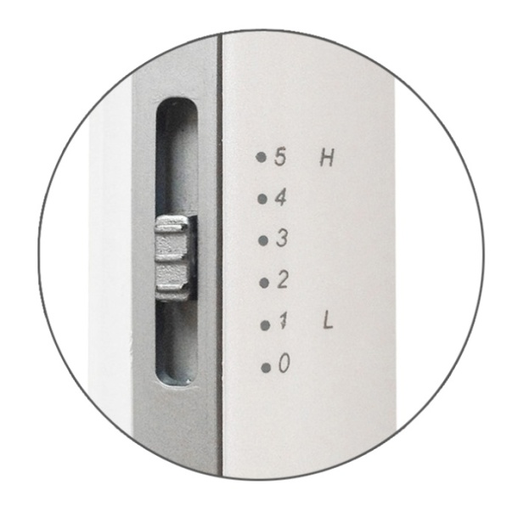
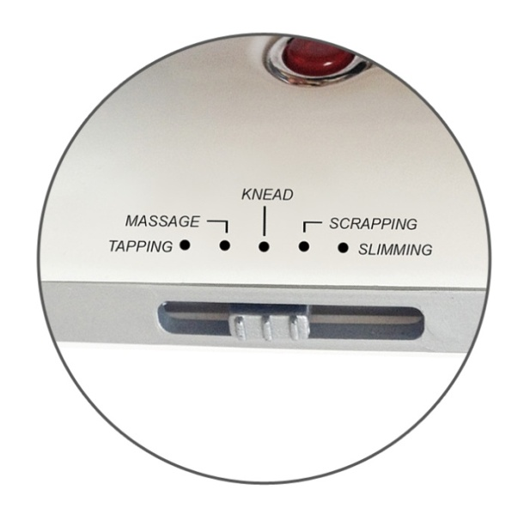

EMS function adjust

EMS intensity adjust
TAPPING
MASSAGE
KNEAD
SCRAPPING
SLIMMING

Ultrasound cavitation function - application process

How to use ultrasonic cavitation function:

Put the thin layer application gel into the treated skin (gel is not supplied) . Application gel called. Sonogel purchased at any store medical supplies (can be purchased at the pharmacy). The gel is for use of the instrument very important. It creates the necessary bonding layer between the application head and skin. It is made based on water. It cannot damage the application head. The use application of the gel is necessary. The device mode ultrasonic cavitation is not possible without the presence of the gel on the skin use.

Connect the power cable into the device (at the bottom). Plug the adapter into a 220V.

Turn on the device, press the POWER button - the button will light red and you hear a beep sound.

Function ultrasonic waves will turn on pressing SONIC.
One press switches on the mode LOW (low) - it will light the LED diode at the letter "L"
A second press switches on the mode HIGH (high level) - it will light the LED diode at the letter "H"

Application head moves on selected body part in circular motions (See. The following figures). NEVER Application head not stay in one place. Ultrasonic cavitation function is automatically preset timer of 10 minutes. After this time, the unit automatically turns off (confirmation beep sound)
Note: Effect of ultrasonic waves is not felt on the skin. Users with good hearing can perceive the long continuous audible tone. To be sure, it is the action of ultrasonic wave function, spray application head a few tiny drops of water. You can then see their oscillations. After this test, wipe dry immediately head.

Illustration of how to move the application head on individual body parts:
chin
decollete

hips
thighs

arm
arm

abdomen
calf
buttocks

Infrared light function - application process
For more effective body shaping recommend during ultrasonic cavitation can also activate the infrared light. Along the perimeter of the applicator head units are built in 4 IR emitters. Infrared rays penetrate into the body in the wavelength range of 8 to 12nm. The infrared radiation in comparison to other sources of heat better ability to penetrate deeper into the subcutaneous tissue. Infrared heat is strongly supported by circulation. The body is then able to quickly get rid of harmful substances and waste products. Contributes to the overall regeneration and recovery of the body.

To use infrared light functions:
1. After you connect the device to the mains cable, press INFRARED button.
2. The function is activated button glows INFRARED and 4 LEDs around the perimeter of the applicator head.
3. During the movement across the skin will feel warmth.
4. Functions of infrared light turns off automatically after 10 minutes or can be switched off by yourself pressing INFRARED button (LEDs and button is off).

Please take the time following instructions in order to use the device correctly and safely.
Electrostimulator - application process

Dangerous

Electrostimulator use is prohibited, unless simultaneously using these devices:


1. Medical electronic devices (eg. A pacemaker).
2. Such medical electronic devices that support vital functions
(eg. An artificial heart, lungs, liver, etc.).
3. Other medical devices (eg. Electrocardiograph).

Warning

If you suffer from the following health symptoms, contact your doctor or medical help:

1. acute problems
2. heart problems
3. the High fever
4. pregnancy
5. malignant tumors
6. persistent low or high blood pressure
7. infected wound or similar serious injury
8. allergic skin problems
9. submission to medical diagnostic therapy
10. inconvenient continuous muscle pain due to their excessive overload

If you are affected by any of the above, it is forbidden to use the electrostimulator.

Observe the following guidelines:

- It is prohibited to place the electrode in the area of the heart, neck, head, into the genital area. Do not use electrodes to areas which suffer from skin diseases or scrapes.
- The instrument must not be used in combination with other medical devices. Before using do not use creams or sprays. This could cause damage to the skin.
- The device use according to a strict instructions in this manual. The device must not be used for purposes other than combat muscle pain, tension and muscle strengthening.
- Electrodes that are part of the package. They are designed exclusively to connect to the electrostimulator device.
5. The apparatus themselves not repair, disassemble, remove any of its components. The guarantee would then lose its validity and possibly caused damage to health or property we would not take no responsibility.
6. Without previous careful study of this manual must not use the device.

Notice

1. If you feel bad when using the machine or there are unexpected medical complications, operation immediately turn off and further use consult your doctor.
2. If you want to place the electrode to another part of the body, first turn off the device operation. Then you can safely move the electrode and restart the device.
In recognition of the third to ensure maximum effectiveness of the device, turn off all electronic devices that may be using (MP3 player, cell phone during a call).
4. The unit should not be used in sleep when you're not able to have full control of the unit. This could result in serious injury.
5. Electrode use in one place for more than 30 minutes.
6. Ensure that during use, the electrode is not in contact with the metallic conductive objects (such as necklaces, bracelets, rings, ...)

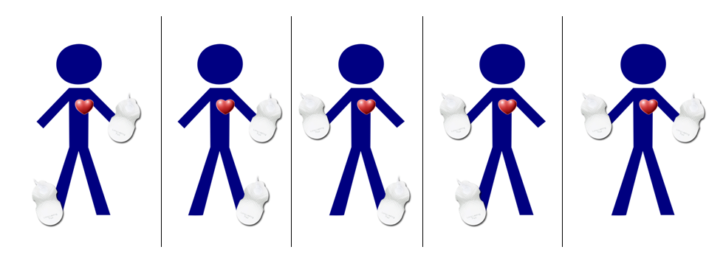
Do not put the electrode pads on body shown in the above combinations. Electrical impulses would flow directly through the heart, which is strictly forbidden!
How to use electrostimulator function

1. First, thoroughly clean the skin where you will apply the gel electrode. This is very important for the correct transmission of pulses through the skin.

2. Each electrode plug to the flat connector.

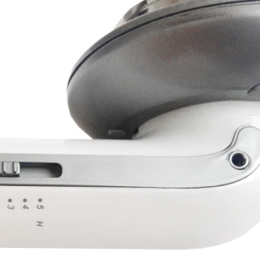

3. Electrodes stick to the body part that you want to treat.

4. Cable electrodes connect to the device. Socket is positioned below the surface of the applicator head cavitation.
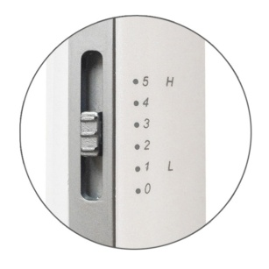
5. Before switching on, make sure the side button on the value of the 0.

6. Once you will connect device to the electric socket, press POWER button.
(POWER button lights up)

7. Press the button EMS (electrostimulator function is ON).

8. The electrical pulses begin to flow through to the skin as soon as you set on the side 1.

9. On the other side of the device, select the mode of electrical pulses that suits you best. There are the following:

These modes are useful for muscle relaxation:
TAPPING
MASSAGE
KNEAD

These modes are suitable for active muscle strengthening:
SCRAPPING
SLIMMING

10. During the treatment by electrostimulator you can change the EMS function:
(TAPPING, MASSAGE, KNEAD, SCRAPPING, SLIMMING). You can change the power level of the EMS function also (0 - off,1,2,3,4,5).

- Electrostimulator will switch off after 10 minutes automatically or you can switch it off by yourselves by the pressing EMS (LED button will lights off).

Note: If you're starting with the device, we recommend that the length of the application of 10 minutes, 20 minutes later. Never use electrical stimulation in one place for more than 30 minutes!
You can see in the picture how to apply electrode pads on the body:

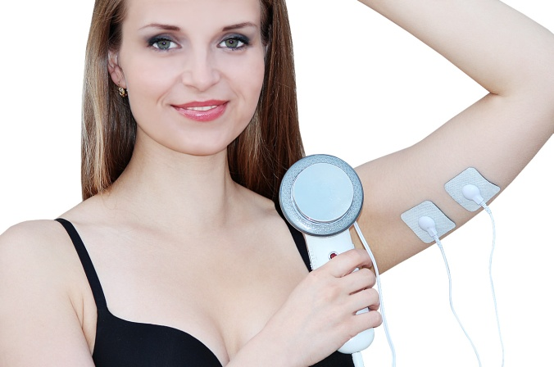
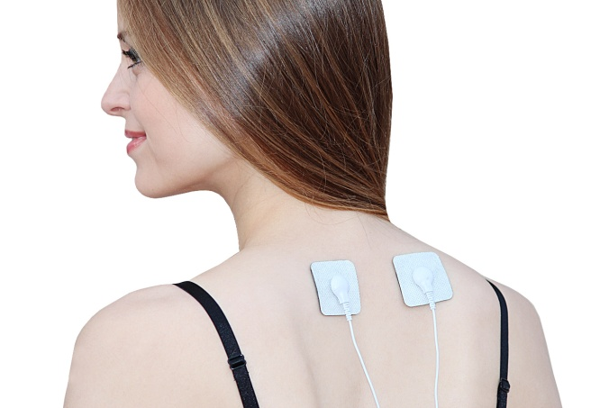
shoulders
arm

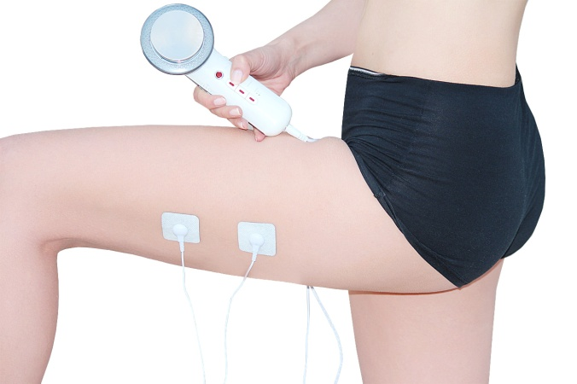
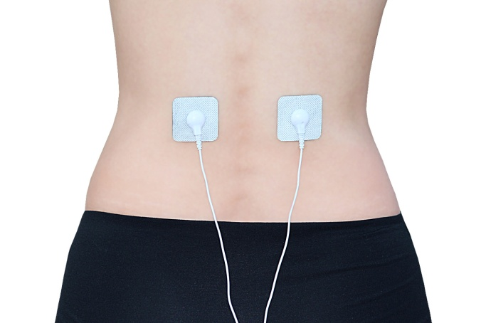
hips
thighs

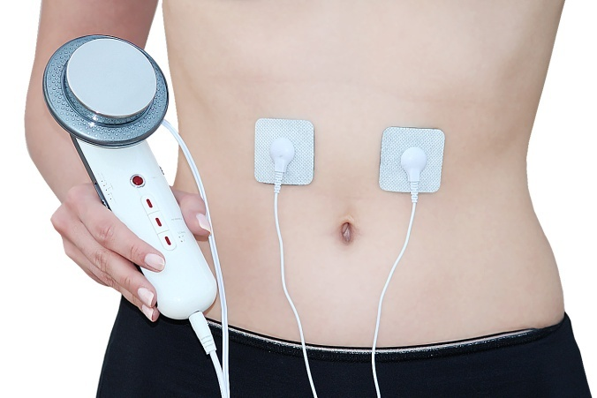
abdomen

F.A.Q. [cavitation function]
What is an ultrasonic cavitation?
Apparatus for home cavitation generated through large applicator head ultrasound waves that penetrate the skin. Tissues then absorb this ultrasonic energy. The disruption of the integrity of the fat cells and the fat is released. Released fat is cleaved to glycerol and free fatty acids. Glycerol serves as an energy source, while the fatty acids are transferred into the liver, where they are treated as normal fatty acids from food and excreted from the body naturally. The removed fat tissue back into refunded. Ultrasonic cavitation is a painless, non-invasive, gentle, effective and most permanent method for removing fatty tissue, cellulite reduction and skin smoothing.

How should the treatment be carried out properly at home?
Before starting treatment with a very carefully read all the details mentioned in this manual. Pay special attention to particular contraindications. If you are unsure, use your GP. Please also list lots are for treatment of ultrasonic cavitation precise. During treatment, assume a lying or sitting position. Create adequate comfort.

Jaké opatření je před a po ošetření nutno dodržovat?
Minimálně 4 hodiny před ošetřením ultrazvukovou kavitací nejezte těžká nebo mastná jídla. Doporučujeme lehká jídla (např. zeleninový salát, jogurt). Den před ošetřením, v den ošetření a několik dní po ošetření zvyšte váš pitný režim na 2 až 2,5 litru čisté vody denně. Vyhýbejte se perlivým a slazeným vodám. Týden po ošetření ultrazvukem byste se měli vyvarovat konzumaci alkoholu, kofeinu, nikotinu, těžkých a mastných jídel. Všechny tyto faktory zatěžují vaše játra, která jsou již tak zatížena filtrováním uvolněných tuků z vašeho těla. Další jejich zatížení by mohlo vést k nevolnosti. Po ošetření doporučujeme zvýšit pohybovou aktivitu. Zvýší se krevní oběh a celková látková výměna, která podpoří vyplavení uvolněných tuků ven z těla.

Which action before and after treatment to be observed?
At least 4 hours before treatment with ultrasonic cavitation do not eat heavy or fatty foods. We recommend light meals (eg. Vegetable salad, yogurt). Day prior to treatment, the treatment day and a few days after treatment, increase your fluid intake of 2 to 2.5 liters of pure water per day. Avoid fizzy and sweetened waters. A week after ultrasound treatment you should avoid alcohol, caffeine, nicotine, heavy and fatty foods. All these factors burden your liver, which are already burdened by filtering loose fat from your body. Further the load could lead to nausea. After treatment we recommend increasing physical activity. Increases blood circulation and overall metabolism that promotes released fat flush out of the body.

Is treatment painful device?
Treatment with ultrasonic waves is completely painless.

How do I know that ultrasound devices really work?
During treatment, you will only hear a slight squeaking high, which publishes an ultrasound. Sensitive individuals may feel a gentle tingling. As a test, you can apply a small amount of water drops on the application head. Ultrasound waves vibrate water molecules.

What results can be achieved?
The result is greatly influenced by several factors. A relaxed body fat must be processed. How fast it processes depends mainly on the rate of metabolism, the type of your fat condition lymphatic system or regimen. Under optimal conditions it may be several centimeters loss after repeated treatment.

Ultrasonic cavitation is safe for the body?
If the instrument is used in the right parts, and users do not match any of these contraindications, ultrasonic cavitation is absolutely safe. The released fat is the body can gradually handle.

What principles is essential to adhere to the desired slimming effect came?
As mentioned in the foregoing, it is necessary to modify the diet and increased fluid intake. Treatment ultrasonic cavitation can safely undergo after 7-10 days. We do not recommend treatment more than two batches simultaneously. If the caregiver of games that are closer together, cavitation effect is multiplied. Otherwise (remote parts) with effect splits.

Certification

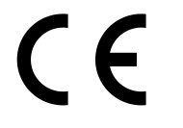
The product is approved for use in the European Union and CE marked. Declaration of Conformity and all documentation is available from the importer.

Importer

SANTADRIA s.r.o., Mojmirovo nam. 75/2 Brno, 612 00
company ID: 29195454 | VAT: CZ29195454

If you have any questions regarding the product, please do not hesitate to contact us:
Email: rma@santadria.cz

Printing errors, properties, and changes in technical parameters reserved.

