Technaxx® User Manual
4-Port USB Magnetic Smart Charger TE10
The Declaration of Conformity is under the Internet link: www.technaxx.de/ (in bottom bar “Konformitätserklärung”); Before using the device, read the user manual carefully.

Service phone No. for technical support: 01805 012643 (14 cent/minute from German fixed-line and 42 cent/minute from mobile networks). Free Email: support@technaxx.de

Universal 4-port USB magnetic charger for smart devices with DC 5V input
Features
● Charging of 4 USB devices simultaneously
● Fast and efficient charging with 6.8A
● 2-pin AC input cable for Europe
● Smart IC for auto-voltage detect
● Over voltage and over current protection
● LED indicator
● 35° angle of inclination of the magnetic holder
● Anti-static and anti-interference PCB design for stable charging
● Solid Neodymium magnet plate for secure hold
● High-quality fire and high temperature resistant material
● Soft rubberized finish and non-slip rubber pad
● Different possibilities to attach the metal plate to the mobile device
IMPORTANT: It is your responsibility to check safety regulations in your area to ensure the lawful use of this device.

Technical Specifications
USB charger | Output current max. 5V / 6.8A
Single output current charger | 2x 1.0A and 2x 2.4A
Power supply (input power) | AC 100V ~ 240V, 50/60Hz
Safety | 5V 7A over voltage + over current protection
Material | ABS, Anti-fire class A0
Weight / Dimensions | 330g / (L) 7.6 x (W) 7.6 x (H) 7.6cm
Package Contents | 4-port USB Magnet Smart Charger TE10, 2-pin AC input cable for Europe, 1 metal plate, User Manual

Product overview
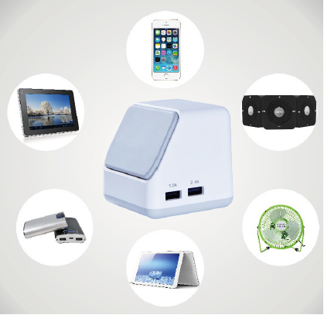

Magnetic plate
USB output:
1.0A / 5V
2.4A / 5V
On each side of
the charger are
two USB ports.

Mounting the metal plate
(1) Install the metal plate inside of phone case or battery cover, directly to your rugged case or directly to your device. First clean the surface of the mobile device, before sticking the magnetic holder on it.

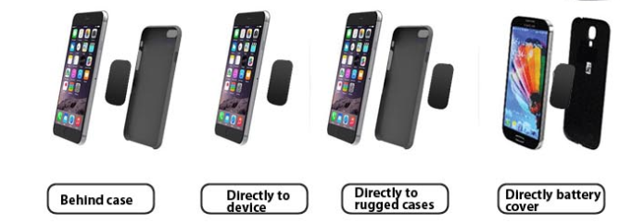

NOTE: If choosing not to attach the metal plate to the mobile device or case, leave the adhesive backing of the metal plate in its place. Position the plate between the mobile device and the interior of the case with the metal surface facing the case.

ONLY attach the adhesive side of the small plate to the interior of the mobile device rear battery compartment cover if space and design permit. Plate will adhere to magnetic mount through rear battery cover.

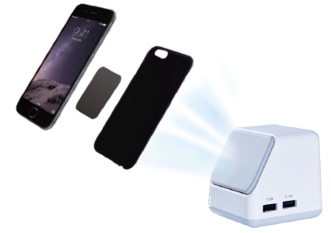
(2) Put the Smartphone with the metal plate on the magnetic holder. It will be supported by strong magnetic power. You can play the Smartphone with hands-free.

Charging function
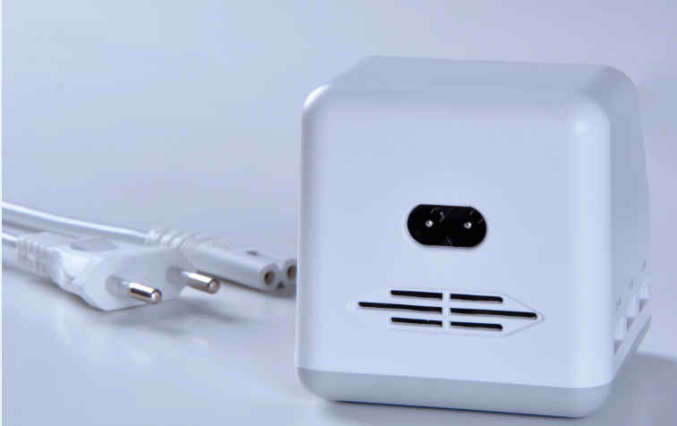
First connect the 2-pin EU cable in the 2-pin port of the charger. Then insert the connector into the power socket.

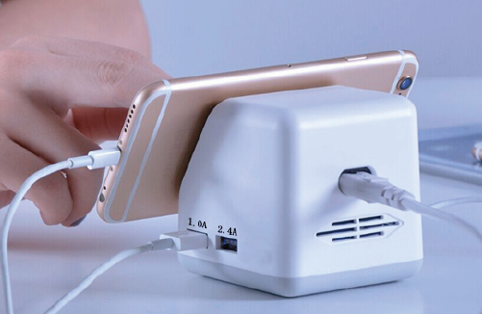
Then connect the USB charging cable of your mobile device to the relevant USB port of the charger. The connected mobile device starts charging automatically. The USB charging maximum output is 5V 6.8A.
The magnetic plate will hold the mobile device steadily on the charger surface (see picture).

Warnings
● Do not attempt to disassemble, drop, shake or dismantle the charger. It may result in short-circuit or even damage of the internal circuit boards or mechanics.
● Do not expose the charger to an environment with high humidity or high temperature, extensive heat or direct sunlight, moist or underwater conditions.
● Keep the surface of the charger clean, but do not use organic solvents.
● Keep the charger away from little children.

Security and Disposal Hints for Batteries: Hold children off batteries. When a child swallowed a battery go to a doctors place or bring the child into a hospital promptly! Look for the right polarity (+) and (--) of batteries! Always change all batteries. Never use old and new batteries or batteries of different types together. Never short, open, deform or load up batteries! Risk of injury! Never throw batteries into fire! Risk of explosion!


Hints for Environment Protection: Packages materials are raw materials and can be recycled. Do not disposal old devices or batteries into the domestic waste. Cleaning: Protect the device from contamination and pollution (use a clean drapery). Avoid using rough, coarse-grained materials or solvents/aggressive cleaner. Wipe the cleaned device accurately. Important Notice: Should battery fluid leak from a battery, wipe the battery case with a soft cloth dry. Distributor: Technaxx Deutschland GmbH & Co.KG, Kruppstr. 105, 60388 Frankfurt a.M., Germany
