BOOX Nova

SMART READING SERIES

User Manual

BOOX Nova
智能阅读系列
用户手册

Table of Contents

1. About ONYX 2
2. Standard Accessories 4
3. Safety Guide 5
4. Product Views 7
5. Main Interface 10
6. Library 16
7. Reading 24
8. Shop 51
9. Note 59
10. Storage 69
11. Apps 70
12. Settings 84
13. FAQ 94
14. Specifications 95
15. Declaration 96
(Note: The E-books in the following illustration are not pre-stored, just for direction)

1. About ONYX
BOOX is presented by Onyx International, which has a group of professionals who dedicate themselves in designing state-of-the-art reading terminal. The beauty of the BOOX is embodied in both its simplicity and its power. As we are going to show you, BOOX is an open and flexible platform for both consumers and content providers.
BOOX is powered by a 16-level grayscale e-ink screen that looks and feels like paper. Passive lighting and diffuse surface relax your eyes and reduce eye strain. By the hand-writing system, you can take notes while reading and sketch up ideas that happen to emerge. BOOX takes full advantage of new-generation e-ink screens: extremely low power consumption without reflection and backlight. Each full charge can sustain a few weeks' reading. By reducing paper consumption while providing a realistic paper-like reading experience, digital content helps to protect the environment without sacrificing convenience or lifestyle.
For content partners, we also provide support for custom formats and digital rights management solutions. All of our viewers have standard features such as layout management, font adjustment, full-text-search, zooming, and page flow.
For a next-generation information device, connectivity is essential. The user can connect to the Internet by built-in Wi-Fi, 3G module or other add-on modules to download new content or surf the web. Customized for the e-ink screen, WebKit, the same software engine as some powerful desktop browsers such as Safari and Chrome, is the web browser of BOOX.
BOOX gives you a new reading experience.

2. Standard Accessories
(1) BOOX Note Reader x1
(2) Stylus Pen x1
(3) USB Cable x1
(4) Quick Start Guide x1
(5) Warranty Sheet x1

Optional Accessories (Purchased separately)
(1) Adapter
(2) Protective case

*Stylus for Nova Pro, handwriting supported.
No stylus for Nova, handwriting unsupported.
The following * means it is only for Nova Pro.

3. Safety Guide
Please read the Safety Guide carefully before you start to use the device. Contact your BOOX retailer if you have any technical problem, or you can dial our official service line at 4008-400-014 or 4008-860-830.

Screen protection
The device is equipped with E-ink screen, which is very fragile. Please have no shocking, squeezing, pressing against the screen, or dropping the device from a higher place. If the screen is already broken, stop using it and contact the professional or other qualified staff to replace the screen for you. Please don’t dismantle the device without our permission.

Standard accessories
Only the battery, adapter, and other accessories meeting our standard safety rules can be used for the device. For details, please refer to Product Specification. We will not be responsible for any damage caused by incompatible accessories.
Stay away from liquids
The device is not waterproof. Don’t expose the device to a humid environment or use it in the rain. Please keep it away from any corrosive liquids.

Don’t dismantle the device
Please don’t dismantle the device in case of any damage.

Using environment
The using environment of the device is 0°C-50°C.

4. Product Views

Front View

BACK

Back View
Power/Standby

Bottom View
Type-C Port

Button Function
Power/  Standby Button | ⚫Press the power button to turn on the device  ⚫Press the power button and hold for 2-3 seconds to turn off the device. Or select “Power off” in the menu to turn off the device.  ⚫Press the power button and release quickly to let the device go standby or wake up.
Back Button | ⚫Exit the current apps;  ⚫Exit the current view or dialog;  ⚫Go back to the previous directory;  ⚫Long press for 3 seconds to turn on/off front light for those models with front lights.
Power Light | ⚫Blue LED indicator lights up when to power on  ⚫In the state of charging or PC connecting, orange LED indicator lights up

5. Main Interface
The main interface contains a status bar, content area, and function area.

The function area contains certain modules.
Double click the icons in function area can return to the main page of the specified module.
Status bar
Content Area
Function Area
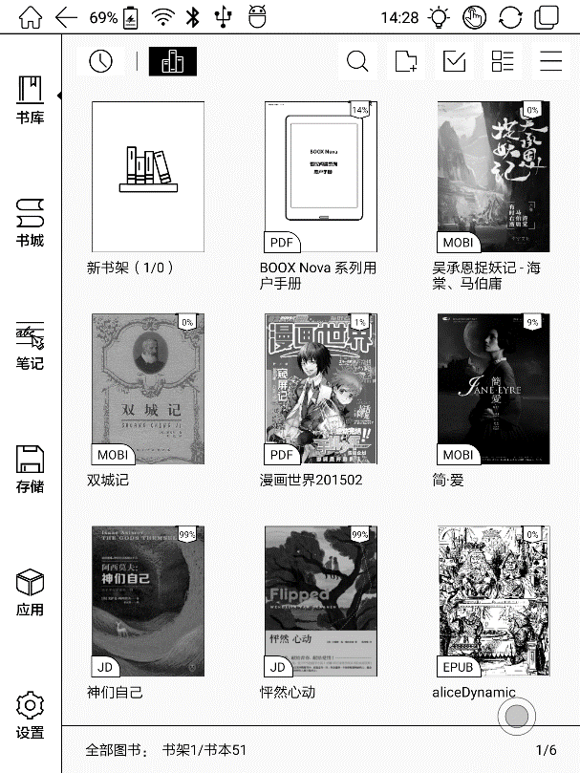

(1) Status bar
This section displays the current state of the device, including Home, Battery Status, Notification, Time, Front Light on/off, Hand Touch on/off, A2 Mode on/off, Multi-tasking switching.

Home
Go back to the homepage of the Library directly.

A2 Mode
Two-grey level refreshment mode is good for a fast refreshment of text pages. It enables fast pageturn, no screen flashing and less ghosting background. When A2 mode is on, reading articles with images, graphics, texts mixed are not recommended because the images may not be fully shown.
A2 Mode is on
A2 Mode is off

Switch between Pageturn / volume
In third-party apps, this indicated button is set as pageturn function by default for the pre-installed application of the device.
Front Light
Call out a panel to adjust front light luminance.
Hand Touch
For palm rejection, hand touch can be turned off (except for the status bar). The default hand touch is on after reboot.

Multi-tasking switching
Clicking this icon, pop up the Android multi-task list to check the running applications in the background, one key to clear up all the applications to speed up the device.

Notification Interface
Click the middle of the Status Bar, the notification interface can be callout. Notification interface contains battery percentage, WIFI setting, Bluetooth setting, power saving mode, volume adjustment, ongoing operation indication, etc.
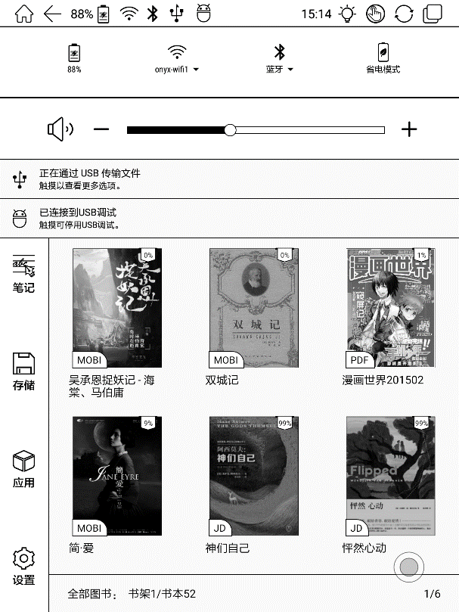

Battery Status
It shows the current state of the battery including remaining capacity, use hour, the curve of the battery percentage.

WIFI Setting
When using at the first time, you should enter into the Wi-Fi setting interface to get a possible connection. Then click the icon to turn on/off the automatical connection.

Bluetooth Setting
When using at the first time, you should enter into the Bluetooth setting interface to match a device you want. Then click the icon to turn on/off the automatical Bluetooth connection.

Power Saving Mode
Prohibit third-party software from running in the background. Help to save power of the device.

Volume Adjustment
Adjust the volume of a loudspeaker or bluetooth earphone, only for the devices without volume buttons.

(2) Function Area
The function area includes Library, Shop, Storage, Apps, and Settings.
- Content Area
The contents are sort by time by default. The contents are:

Library
All books in supported format from internal storage are displayed here. The scanning path can be modified at Settings - Library Settings.

Storage
All folders from internal storage will be displayed here. Users can manage documents and folders from the page.

Apps
All the third-party apps are displayed here. Users are allowed to manage or optimize the apps.

Settings
The list of system settings helps to manage the device.

6. Library
The library only displays E-book documents in supported formats in the storage. Book cover thumbnail is displayed by default. E-books are sorted by the creation time.

Tapping the toolbar icon on the top right of the library, users can Search, Create sub-library, Multi-select, Filter & Sort by, and Rebuild Library.

Library Display Switch
Click on these icons to switch the library display. By default, it automatically scans and loads all the supported documents in the specified path, sorted by a specified way.
Another one is to display the content based on the structure of storage. The icons change after clicking on.
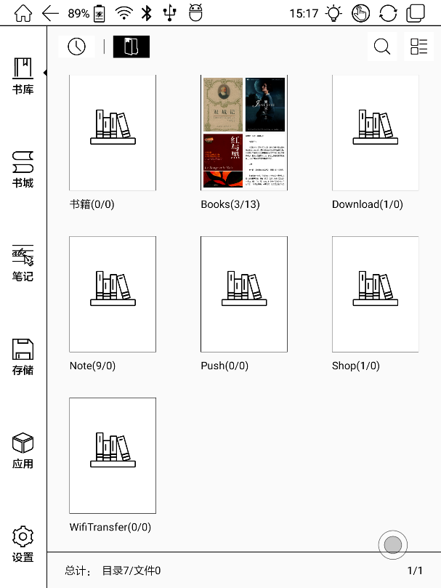

Filter & Sort
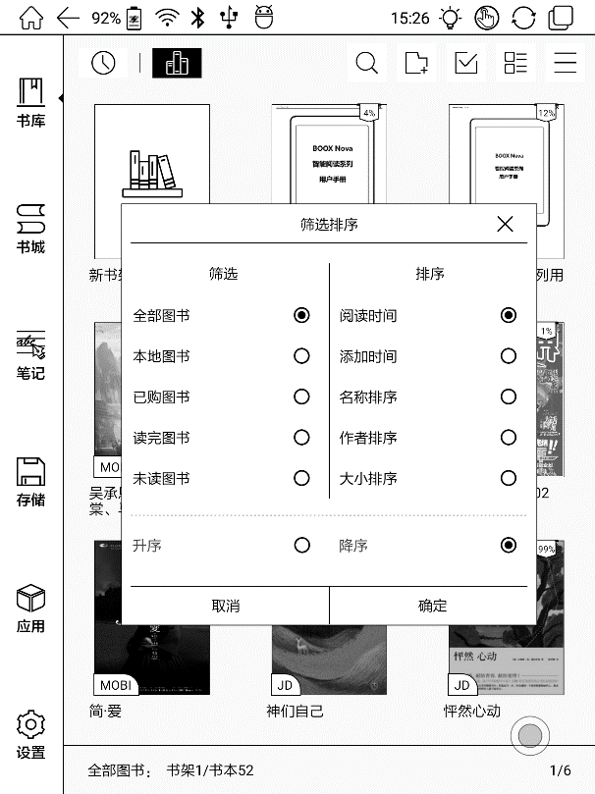

Refresh Library
“Refresh Library” get all documents in supported formats scanned and rebuild library list. This function does not delete the reading history.
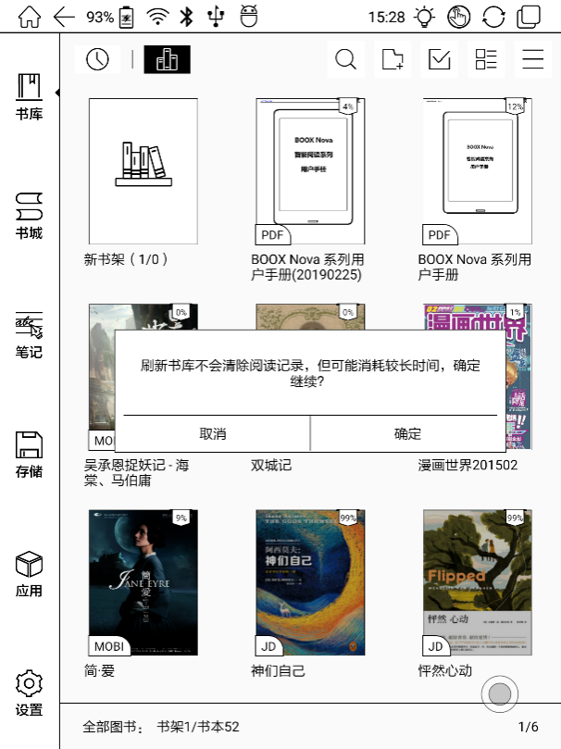

Create Sub-library

It helps to manage books by file manager.
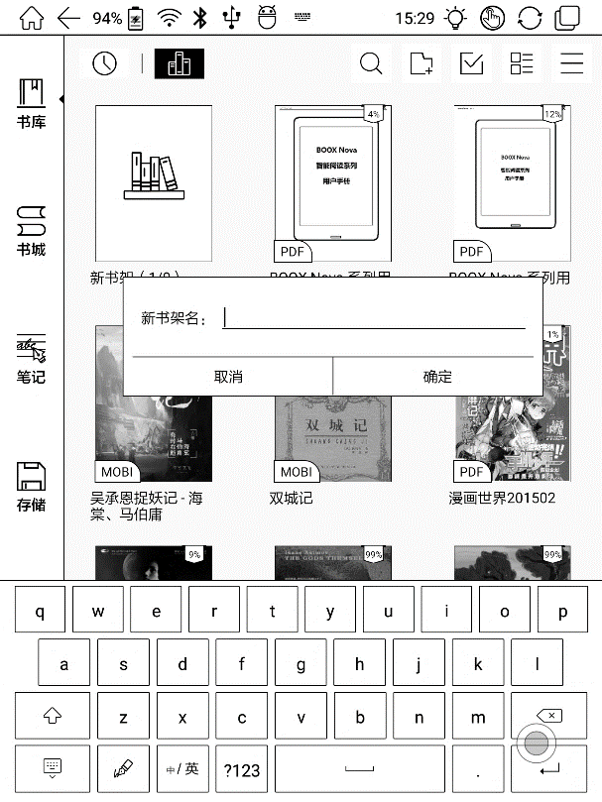

Sub-library Attribute
Long press against sub-library cover to view more information about sub-library. To delete or rename sub-library are allowed. When deleting sub-library, the containing books will be moved to Library and will not be deleted with the sub-library.
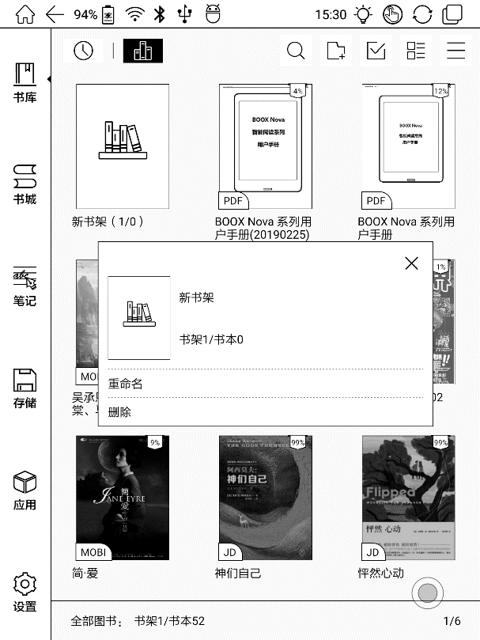

E-book Attribute
Long press against book cover to view more information about E-book name, author, format, size, reading progress, book detail(only available for the E-books of Shop), open way, rename, move(to sub-library) and delete. One E-book only can be added to one Sub-library.
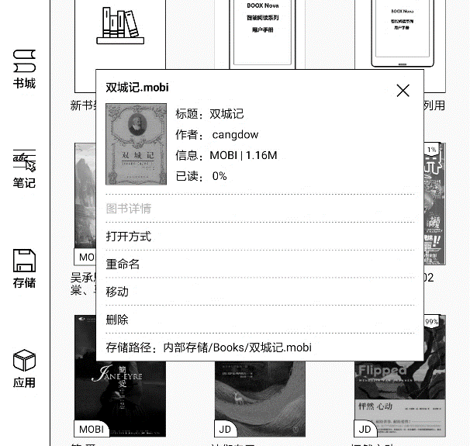
As for the books purchased from the Shop, is allowed to view book details by jumping to the Shop page.

7. Reading
Tap any E-book cover to open an E-book. Full-screen reading without showing status bar is set by default.
To tap on the center of the screen can call out the status bar and menu.
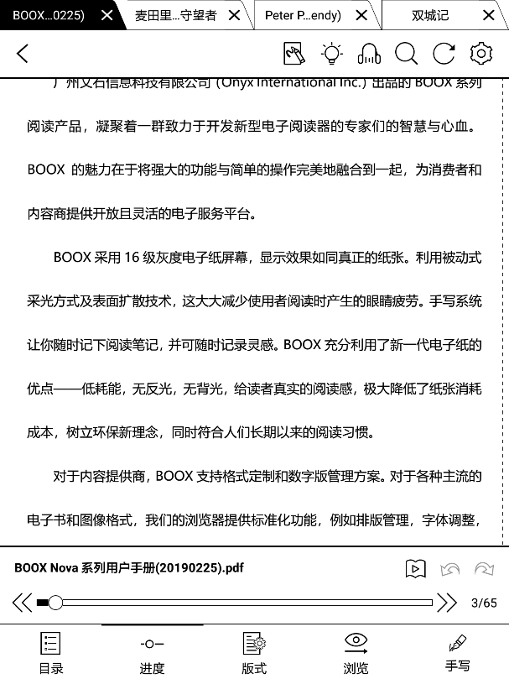

Word Menu
Long press on the word to pop up Dictionary dialog for lookups.
English word recognition and look-ups are supported.
Through the drop-down list on the top right of the dialog, the dictionary can be switched to others.
Users can download and install the dictionary themselves. Put dictionary file on the path root directory\dicts\xxx (e.g Storage\dicts\English-French), or download dictionary online directly. Dictionary is available to use after being installed.
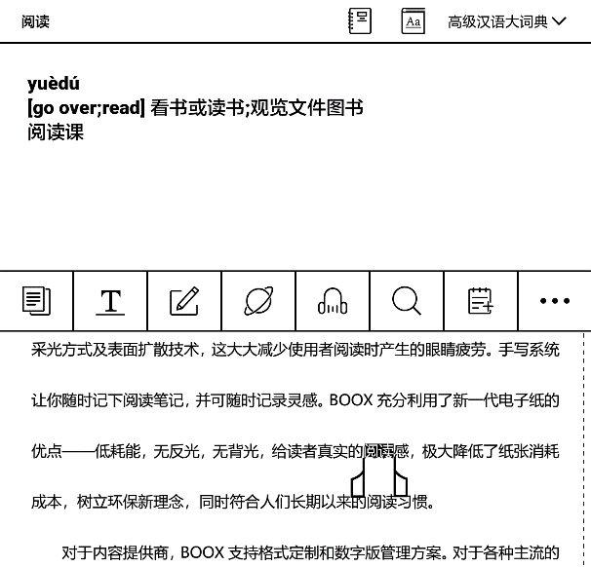
Tap on any position out of the dialog to exit the dialog.
Long press on any word and drag to select the text you want to mark.
The highlight is set by default for selected text. Users can switch among highlight, underline and others, the color highlight can be in black or grey. The mark setting remains after a change. The marks before the change will not be affected.
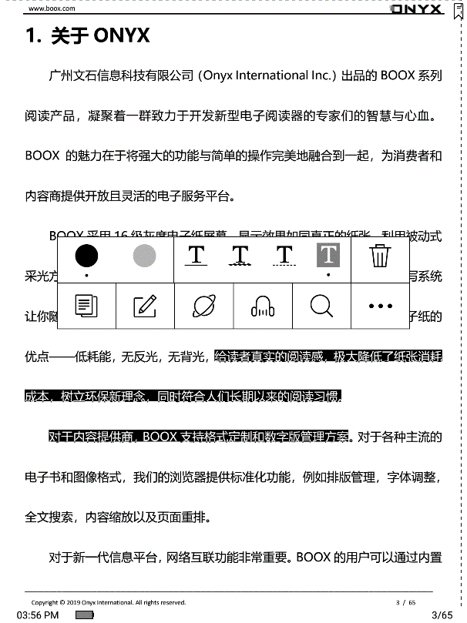
Tap on any position out of the dialog to exit the dialog.

Choose “Annotation” to pop out a text box to add notes if needed.
The status bar includes multiple document tags (4 tags at most), top menu bar and bottom menu bar.

Top Menu Bar
It contains: Back, Quick Writing (for some certain formats), Buy (for E-books of Shop), Front Light, TTS, Search, Refresh, and Settings.
Buy
Only available for the books from the Shop. It jumps to the book detail page to purchase.
Quick Handwriting
For the scribble supported document, the stylus for handwriting is allowed by default. The function can be turned off, then the stylus is used for touch only.
TTS
English supported. Network connection is required at first use.
Refresh
The refresh modes are Normal Refresh (Regal Mode) and Fast Fresh (A2 Mode). Full refresh every specified page can also be set here.
Settings
These reading settings contain Global Settings, Touch Settings, TTS Settings, Export Settings, and Version.

Bottom Menu Bar (for PDF)
Doc, Progress, Format, Navigation Mode, and Scribble are included.
Doc
Doc contains TOC, Bookmark, Annotation, and Scribble.
TOC supports three-layer hierarchy. The current layer is underlined. Jump to the corresponding page when tapping any of the layers.
Tap on any position out of the TOC to exit.
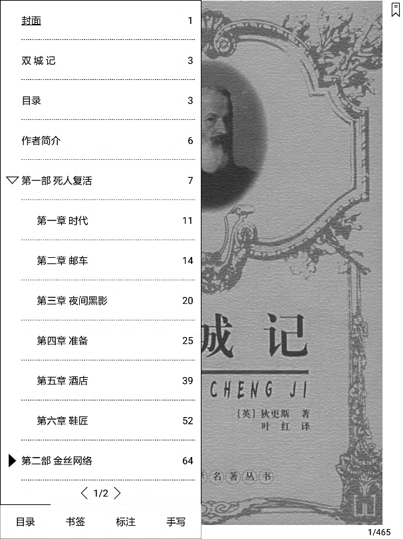

Bookmarks
Without calling out the menu, bookmark the reading page by simply tapping a tag on the top right corner of the screen. Tap it again to un-bookmark the page.
The bookmarks can be checked under the path of Doc-Bookmark, where users can delete bookmarks.
Jump to the corresponding page by tapping any of the bookmarks.

Annotation
All highlighted/underlined/annotated content would be listed under the page of Doc-Notes for further searching, editing and deleting.
Jump to the corresponding page/content by tapping any of the lists.
All contents on the Annotation page can be exported in txt format. Exported files are saved under the directory folder Storage\Note\(same name as the source file).

Scribble
All scribble and sidenote can be viewed under the page of Doc-scribble for further searching and deleting.
Jump to the corresponding page by tapping any of the pages.
All scribble contents can be exported in Png format and saved under the same directory folder Storage\Note\(same name as the source file).

Progress
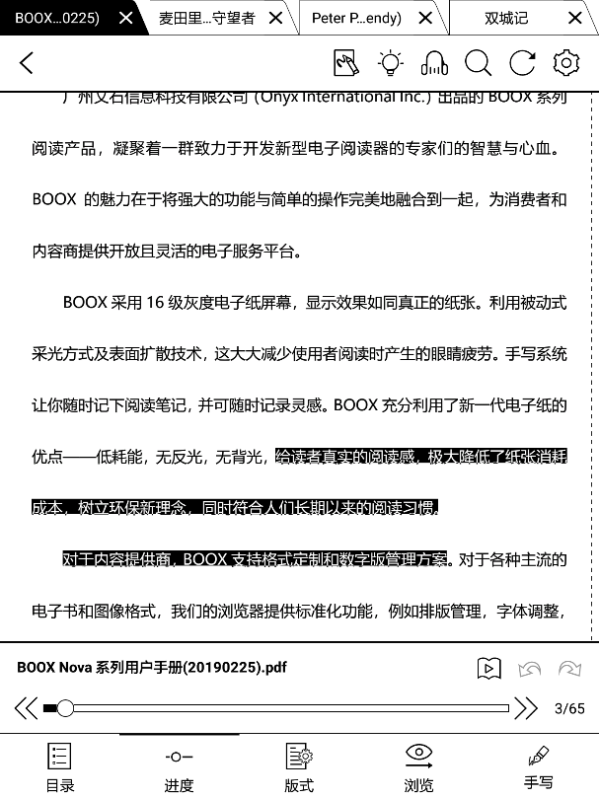
It displays the chapter name (book name if no chapter), page progress, last/next chapter, page number, slideshow, undo, and redo.
Tap on the page number to enter a quick-flip interface. It can be flipped by every 1, 4, 9 pages.
Click the page numbers again and input number to jump to the page directly.
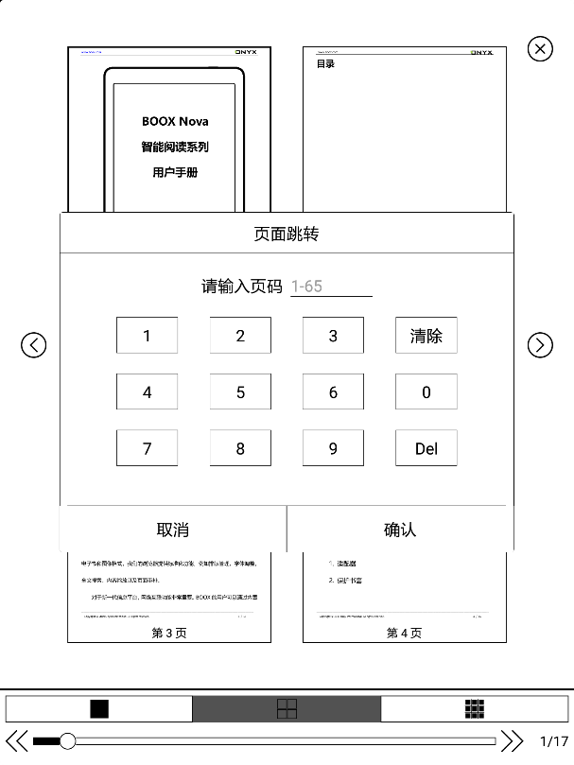

Format
Display, Contrast, and Reflow are included. This module is just available for the E-books in the formats of PDF\DJVU\CBR\CBZ.

Display
It contains Layout, Orientation, Zoom, Crop, and Margin.
Layout: Single page, double pages (only in landscape mode).

Orientation: allowed to switch to four different orientations, the word orientation is the same as the orientation of “T”.

Zoom: Zoom in, zoom out, and partial zoom are supported. Users can also pinch fingers together or apart to zoom out or in on the reading pages.
When zooming in until the whole page larger than the screen display, users can long press and drag to adjust the display area. Single click on the screen to turn the sub-page. Click on the virtual buttons on the bottom right to turn the whole page.

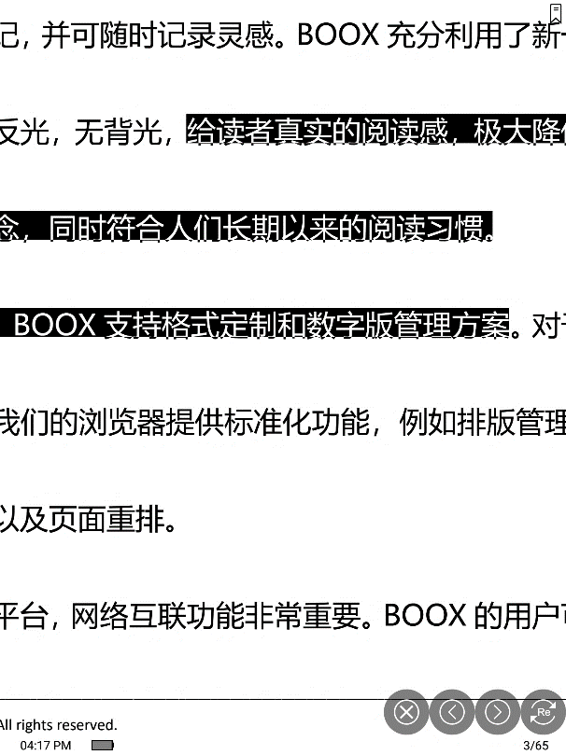

Contrast
Watermark, Sharpen, Image Contrast, Text Contrast, and Bold are included. Some of the functions are just available for scanned documents.

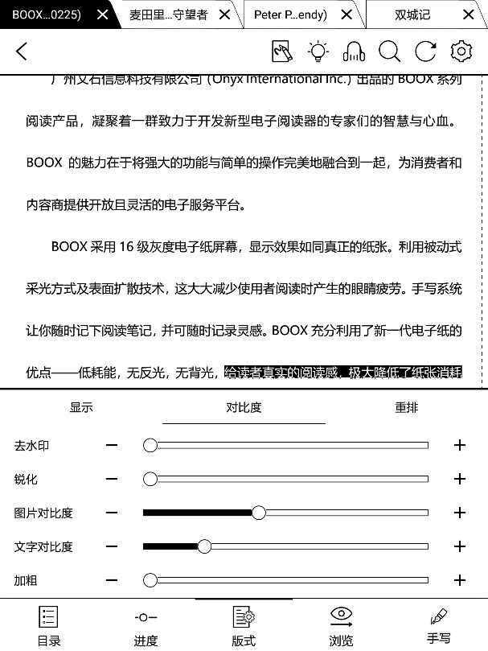

Reflow
Reflow is only available for PDF/DJVU/CBR/CBZ documents.
Reflow allows users to further customize the layout of documents including: Line Spacing, Margin, Text Direction, Font Size, Columns, and Upright (for italic documents).
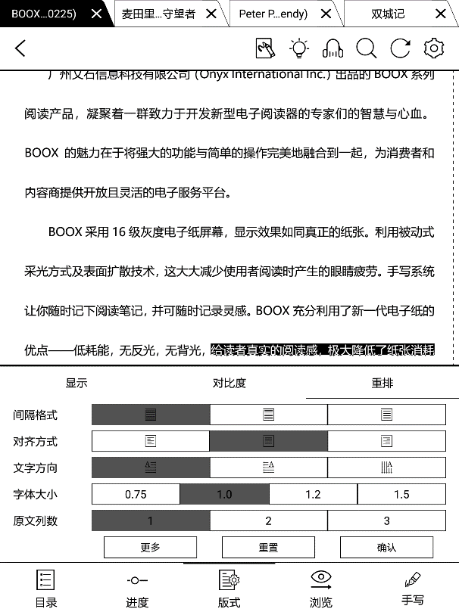

Navigation
Navigation allows users to have options of Reset, Comic Mode, Article Mode, and More Settings including Crop, Split, and Subpage Order.
Comic Mode: the screen will be divided into four subpages and the reading order is upper right – upper left – bottom right – bottom left.
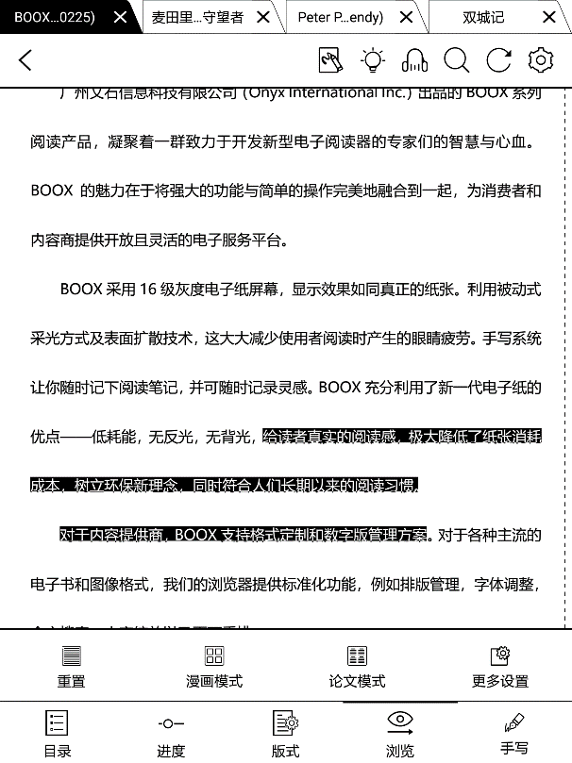
Article Mode: the screen will be divided into four subpages and the reading order is upper left – bottom left – upper right – bottom right.

More settings

Manually adjust the settings of area cropping, page split, and subpage order.
Crop: Manually select the cropping area for single or double pages.
Split: Split the pages into specified subpages in different ways.
Order: Decide the initial position and reading order for subpages.
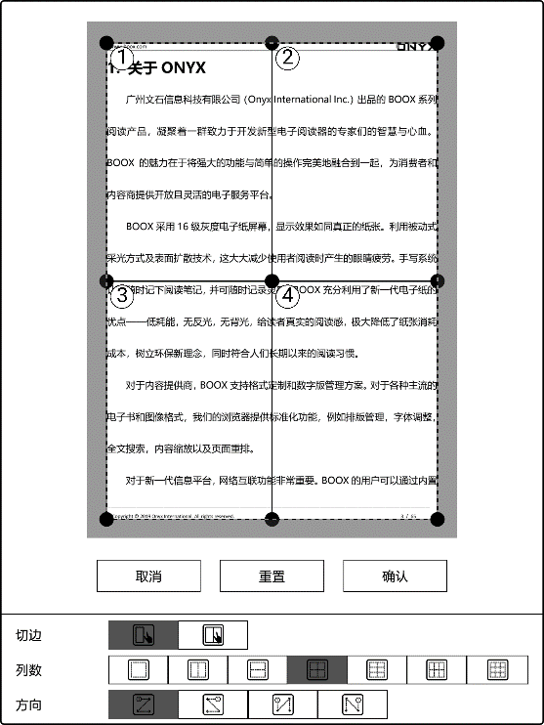
Scribble
Handwriting scribble is on by default. It can be turned on/off on the top menu bar.
The scribble could be called out by tapping on the bot menu bar Scribble.
The scribble content will be directly saved to the original documents, or exported to PDF.
Pen with Pressure
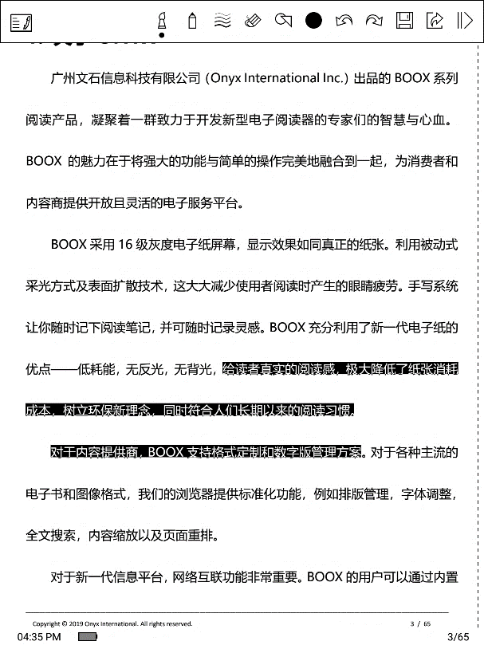
Pen without Pressure
Back
Export
Color
Sidenote

Color
The black and white strokes are shown as their authentic colors. Other colors are shown as black on devices, and the corresponding colors after being exported to PC.
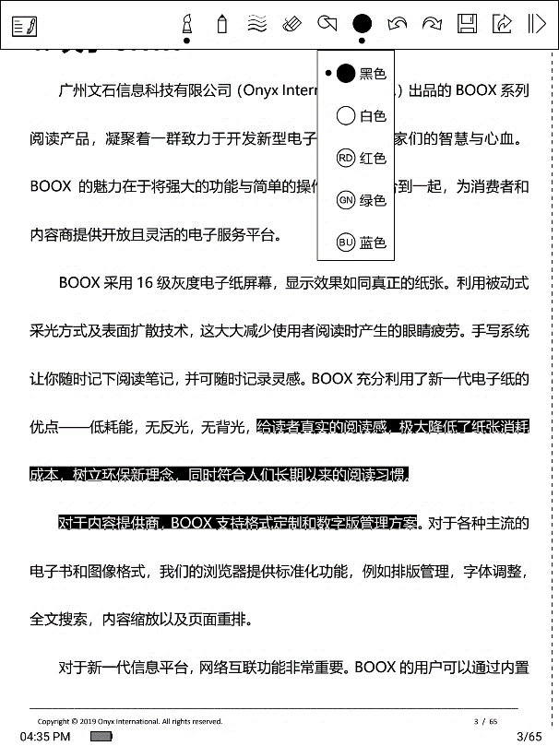

Sidenote
The sidenote function split pages into two parts in landscape mode, the left side shows the document contents, the right side is blank for note taking. These two sides can be swapped to each other.
The menu is the same as the scribble menu.
The sidenote is only associate with documents instead of pages. The document pages and sidenote page can be turned respectively.
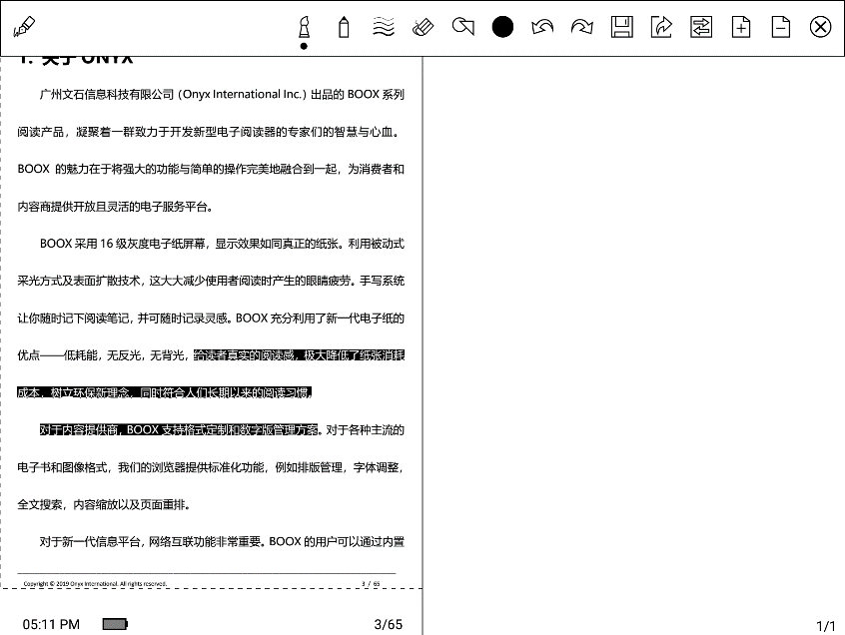
Unlike the scribble, the sidenote will not be embedded to the original documents. It could be exported manually if needed.
Bottom Menu (after reflow)
Doc, Progress, Format, and Scribble are included. It supports the formats of EPUB\TXT\MOBI\AZW3.
All the functions are available except for the module Format.
Scribble is NOT allowed after reflow.
Only sidenote is supported for note taking. The sidenote is only associate with documents instead of pages. The document pages and sidenote page can be turned respectively.

Format (for font adjustable E-book format)

The settings include Font Face, Display and Spacing.
Load font face in the directory Storage\fronts is supported.
The settings for font size, font face, contrast, bold, spacing work on all newly opened documents, but not work on the documents before settings.

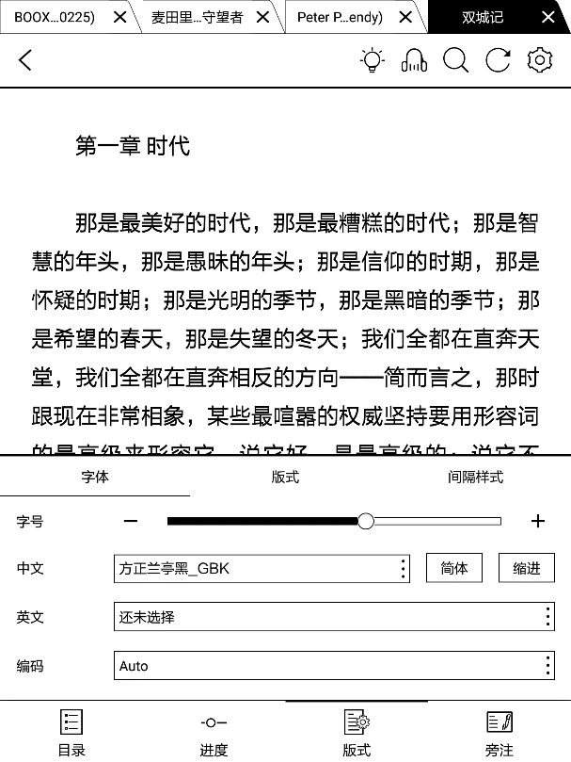

Screenshot
Diagonally tap on two corners of the screen to capture the screen in PNG format. The function is only available on the reading page.
The screenshot will be saved to the local, or shared by scanning QR code. The save path is \Screenshots.
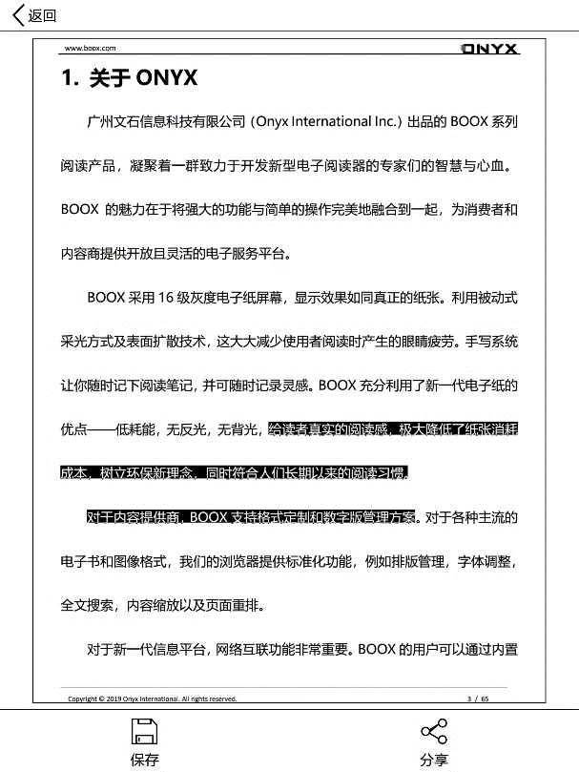

WeChat and browser scanning are supported for screenshot sharing.
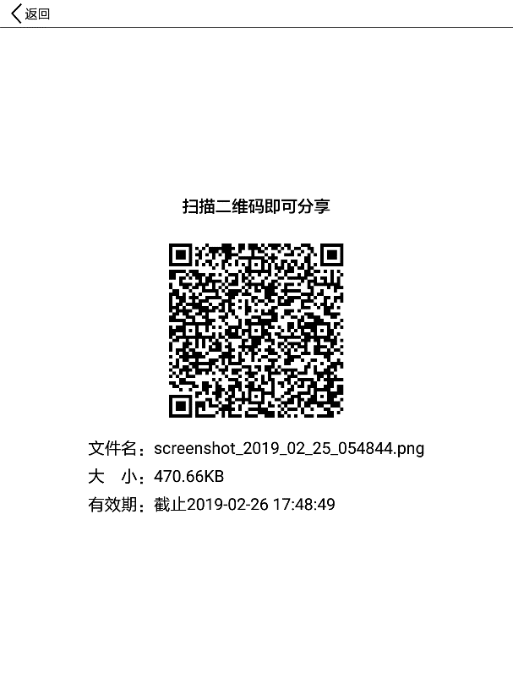

Settings
There are Global Settings, touch Settings, TTS Settings, Export Settings, and Version Name for Reading.
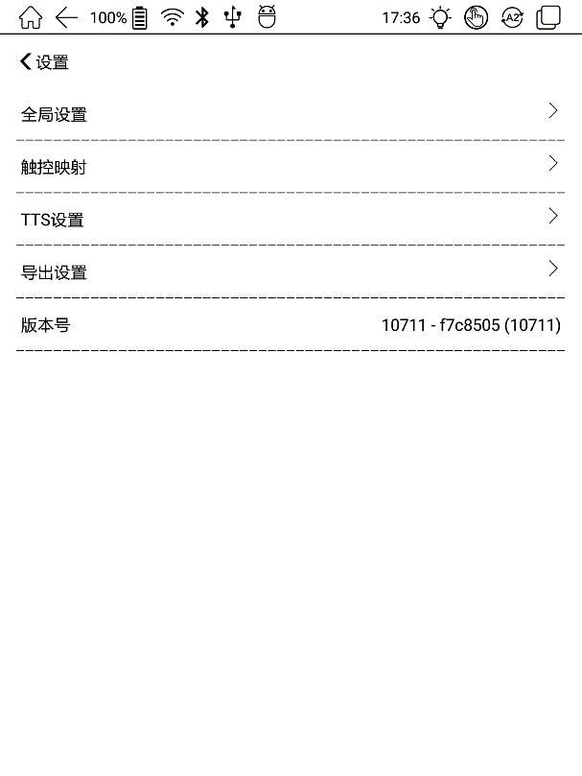

Global Settings
There are Enable page close reminder, Enable system status bar, Enable reader status bar, Show file borderline, Show virtual buttons in zoom state, Show hyper link.
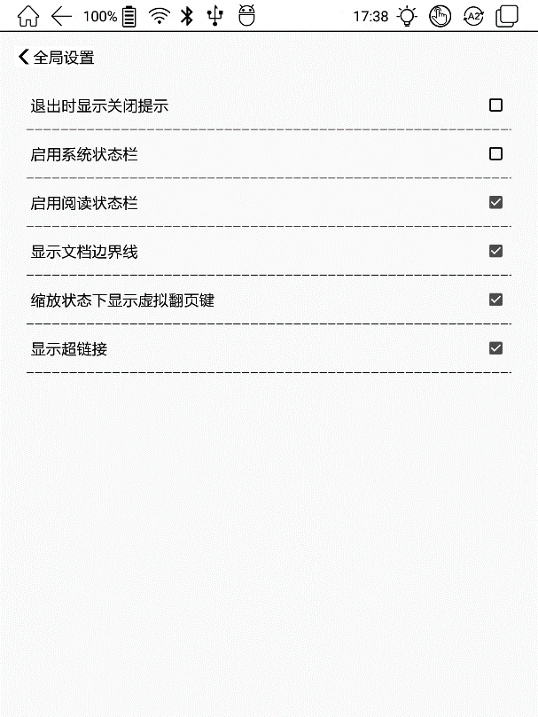

Touch Settings
Except for the center of the screen, users are able to customize the touch settings for different areas.
There are five default touch models can be chosen and users can customize three more.
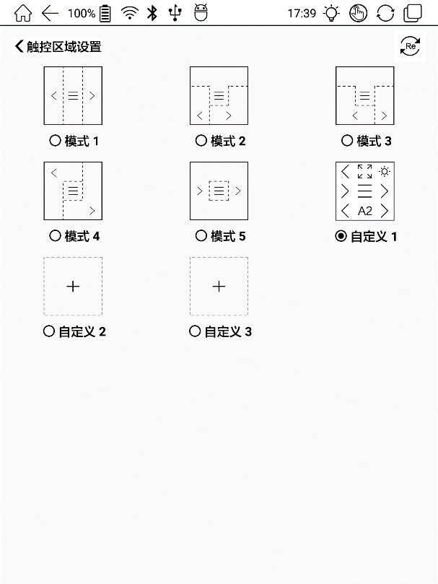

TTS Settings
The built-in Baidu TTS is set by default. English is supported. Network connection is required at first use.
Switching to third-party TTS system is allowed. The built-in TTS settings are not synchronized with the system TTS settings. The system TTS settings work on the third-party TTS by default.
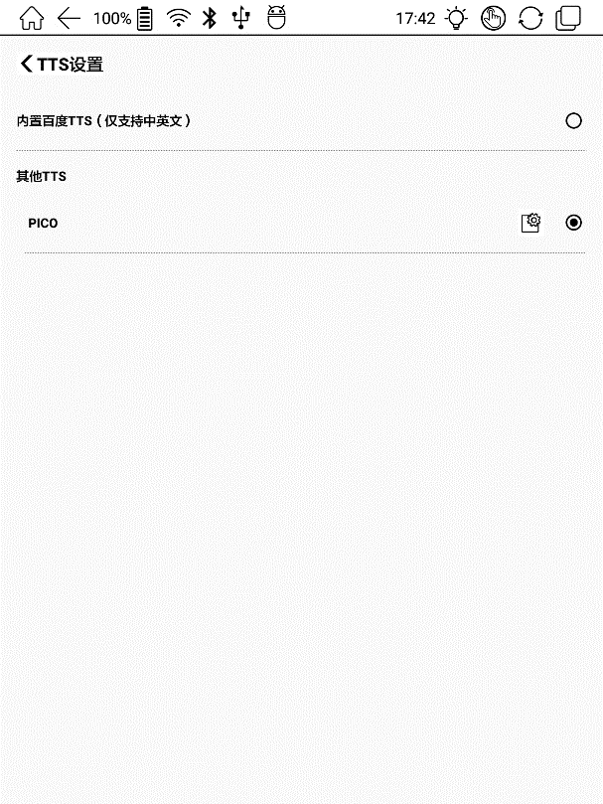

Export Settings
The default storage path is Storage\Note.
The export files can be also saved to the same directory as the source file.
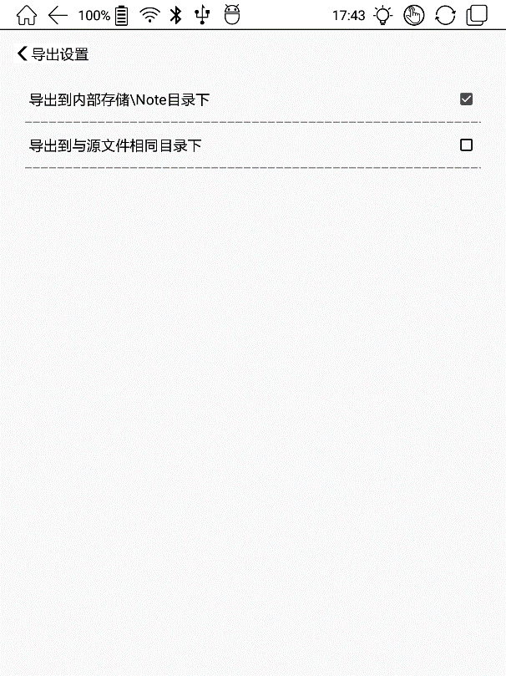

Shop

The Shop is powered by JD.com Inc., offering genuine E-books to purchase. The new users can sign up and login. JD account with purchased E-books is supported. It is currently not available for the synchronization of reading progress and note of JD Reading App.
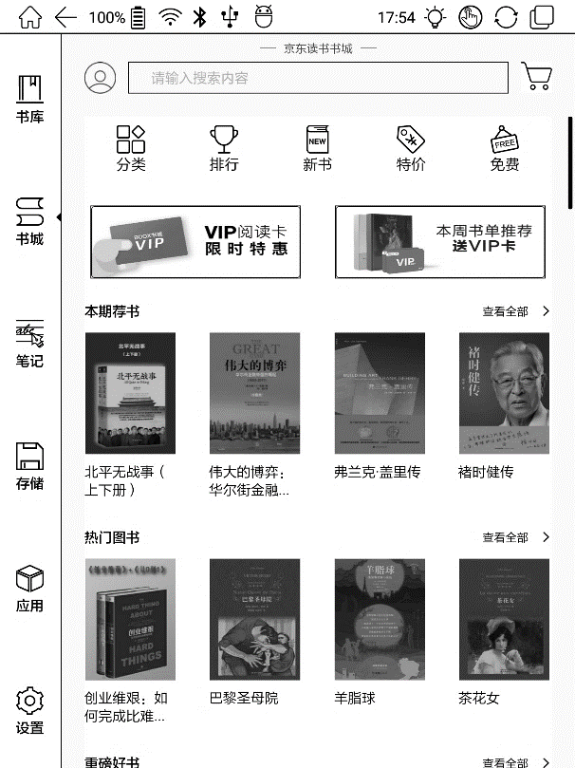

Login and Sign up
Account and password are required for login and signup. JD or WeChat QR code scanning is also allowed.
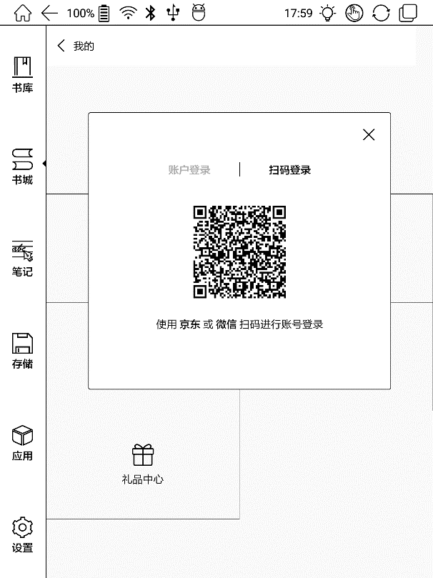

After login, you may enter profile by clicking the profile icon on top left.

Personal Books
The list contains the purchased, preview, and VIP borrowed ebooks.

Personal Account
It includes top-up, records of consumption, records of payment, JDReading VIP.

Reading Preference
Based on the reading preference, the system can offer better ebook recommendations for users.

Personal Task
Finish the tasks to earn read beans which can is expense deductible for ebook purchasing.

Gift Center
The shop aperiodically offers gift packages here.

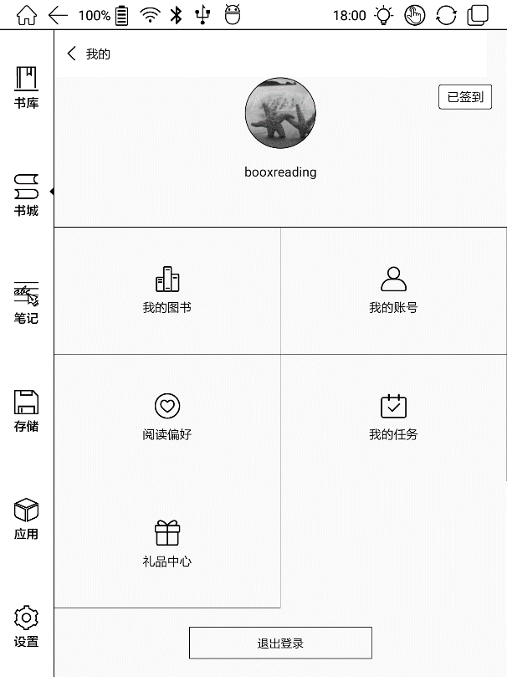

Category
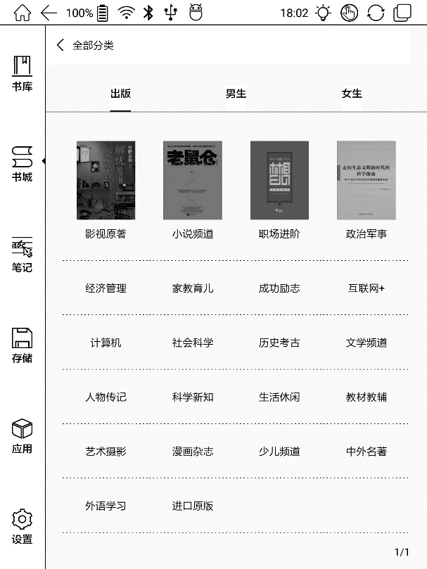
The home page of the Shop contains Ranking, New Book, VIP, Category, Free Book and Sale Book on top. The book information keeps updating aperiodically that users can search the books conveniently.

Book Detail
Click a book cover to open up book detail. The specific book information, price, preview, purchase, abstract, table of content, comments and copyright. All books allow preview for a few chapters. Click “Preview Download” to preview and purchase is available during this reading.
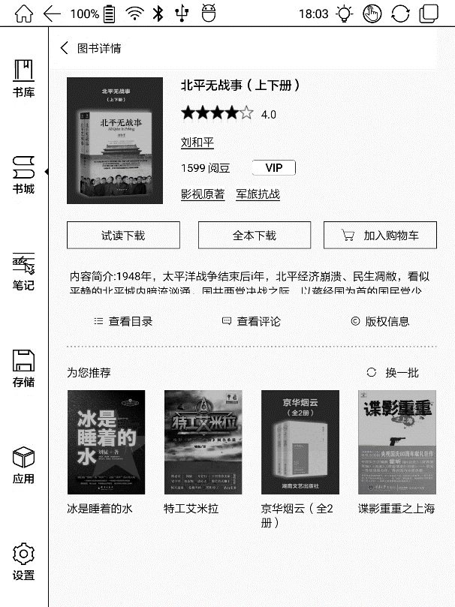

Purchase and Payment
Select books to purchase and add to cart. The E-books can be paid by Read Bean or cash.
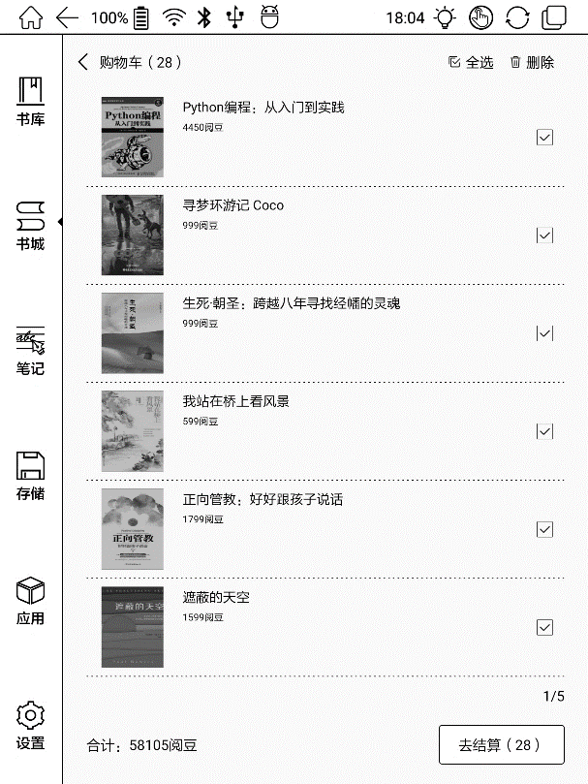

VIP Account and VIP Ebook
Users own a VIP account that has some extra rights. VIP E-book is one of the rights that VIP users can borrow for free.
VIP users can read E-books with VIP icon for free until the VIP account is expired.
The VIP E-books can be purchased and it is readable even it is out of stock.
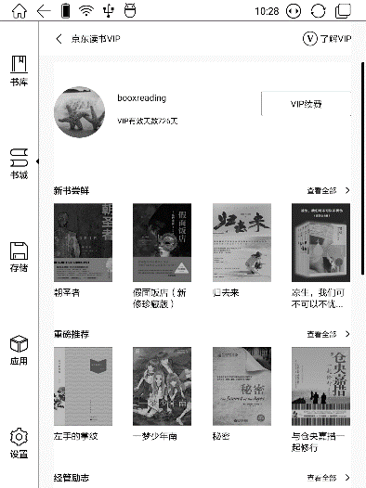

Note
Note List
To create new files and folders are allowed.

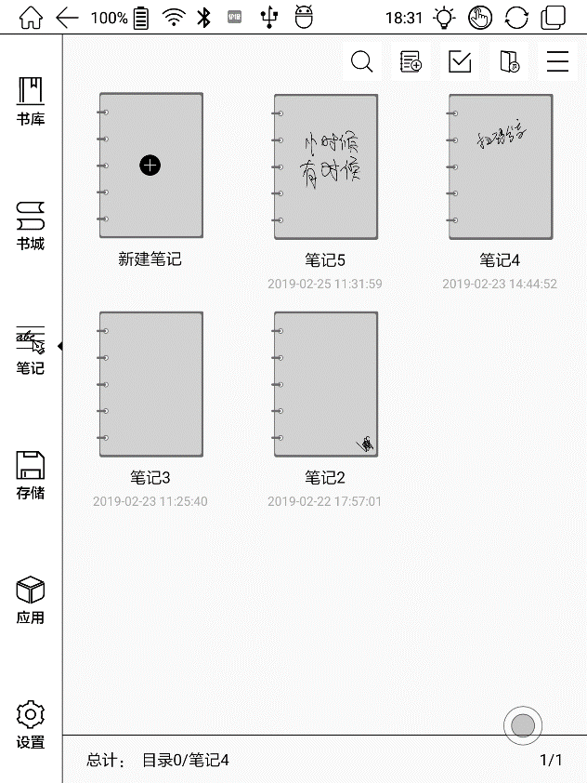
Multi-select
Jump to export folder
Drop-down list
Add Note
Drop-down List
It contains Sort by Time (default), Sort by Name, New Folder, Backup and Restore, and Settings
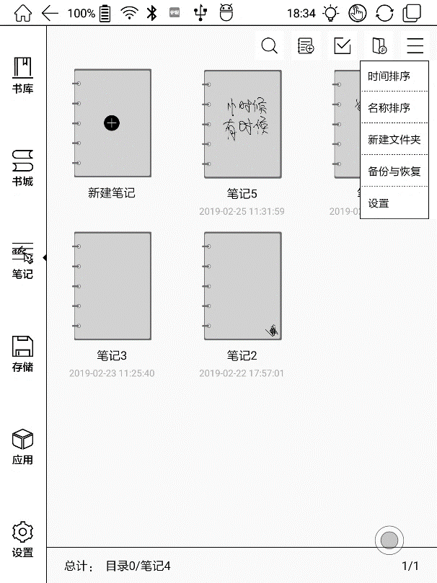

Folder
Long press on the file icon to pop up the option of moving the files to designated Folder. Multiple layers can be made in the folders.
One file can just be designated to one folder.
The folders are just for better file management. They would be not created in the storage. The note files are readable in storage after being exported.

Backup and Restore
It supports backup and restore for handwritten documents in local or cloud backup mode.
It supports to delete backup files.
Note: The action Restore will recover the backup data, which will cover the current data. Please be careful.

Settings
This is a general setting for the application Note, including Stylus Calibration, Account Sync and Backup, Show Erasing Trace, etc.
If this device is bound with third-party accounts for file sync, and WIFI is connected, the Note files will be automatically uploaded to the account in PDF attachment.
If auto-connection with Wi-Fi is on for notes sync, the device will connect with Wi-Fi automatically and sync notes to the cloud. When the sync is completed, Wi-Fi will be turned off automatically. (Wi-Fi hotspot should be saved and connected before).

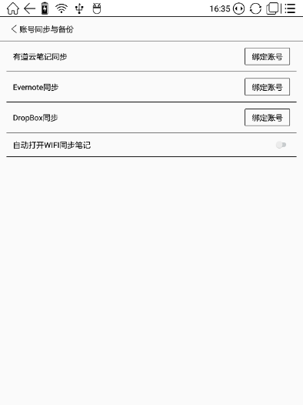
Scribble Interface
Files can be saved automatically and manually when to quit the Note.
Tap on the page number to jump to the specified page quickly.
Add/delete page
Fullscreen
Name
Save
Undo Redo
Thumbnails

Search
Pressure pen

Normal pen
Shape
Erase
Select
Text Input

AI Recognition

Weight

Color

Templates

Palm rejection
Export
Share
Refresh
More

Select
In the select mode, circle an area on the screen, then users can zoom, move, duplicate and remove the selected area.
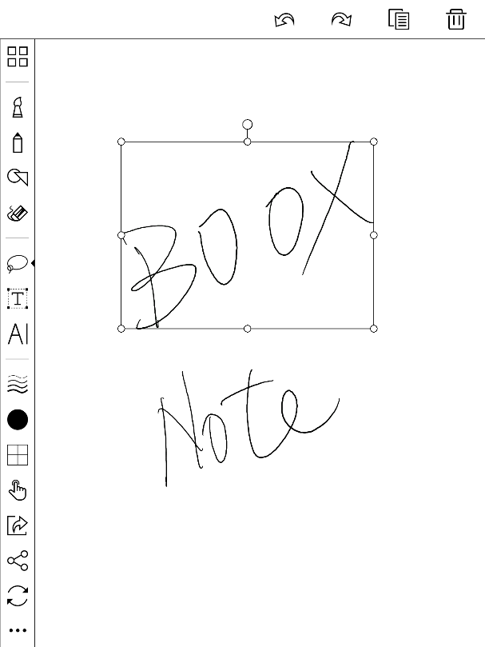

Text Input
Users are allowed to key in words on the note by a Bluetooth keyboard. The input box can be moved everywhere.
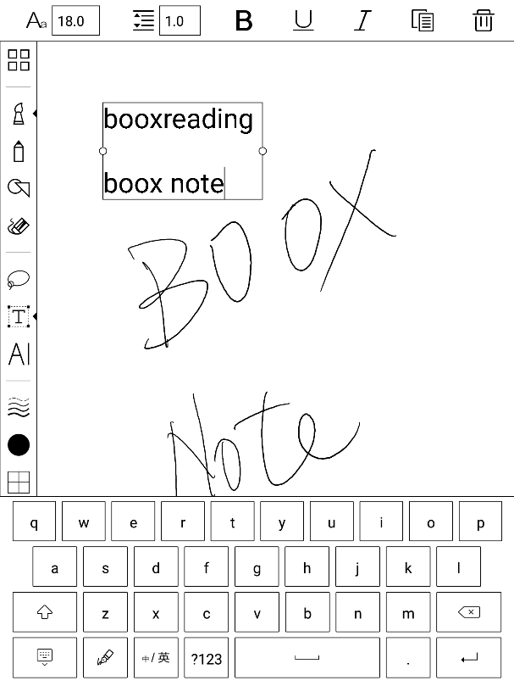
Users can adjust the font, line spacing, bolding, underline, italic, copy and delete.

AI Recognition
Click the icon “AI” to switch to recognize the handwriting text. English is supported. To download the corresponding language package is required for other language recognition.
The text flows automatically after reflow. Users can manually make space, newline, and font size after that.
The accuracy of recognition depends on how normal the handwriting is.
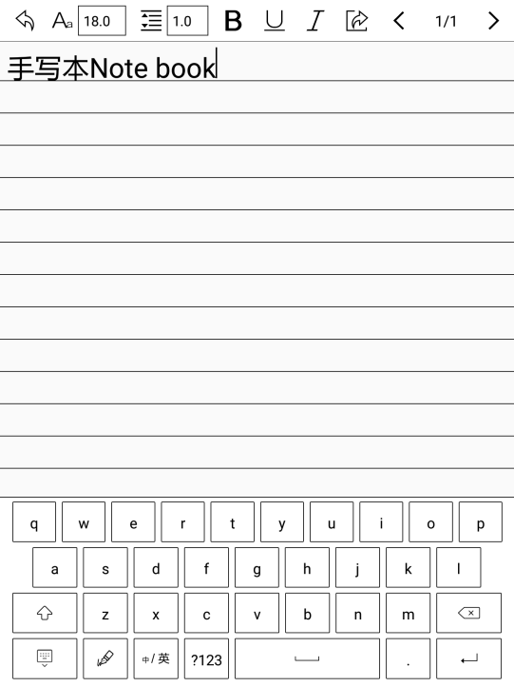

Template
It includes built-in templates, local templates and cloud templates.
The directory of the local templates is Storage\note Template.
The directory of the templates downloaded from the cloud is Storage\noteTemplate\cloud.
The built-in templates will be used if the local template are deleted.

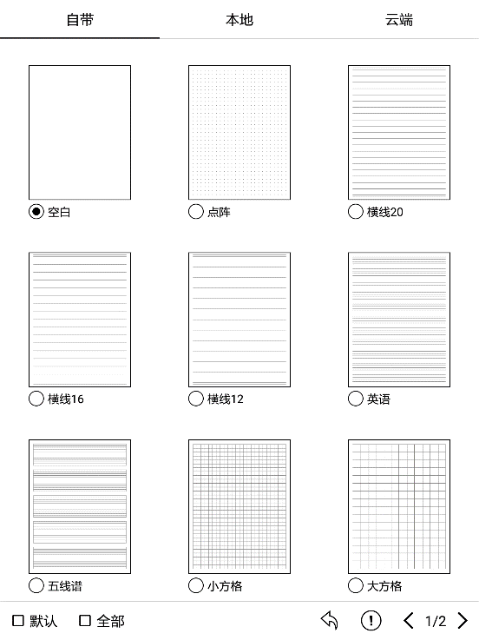
Share
Share all pages of a note in PDF format and current page in PNG format.

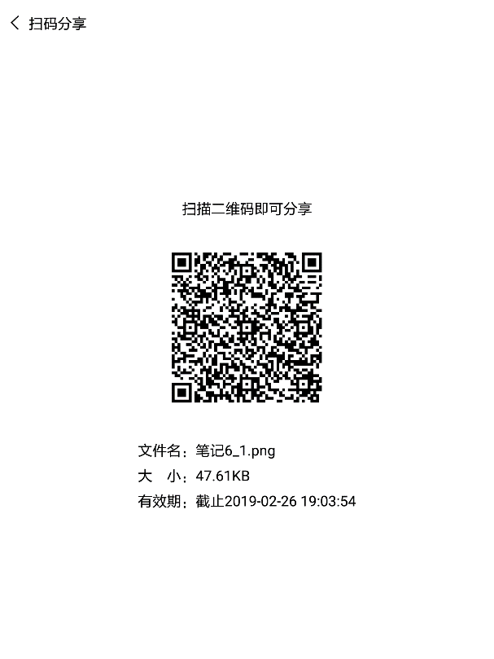

10. Storage
Storage displays all files from both internal storage.
Files will be displayed in alphabetical order by default. It can be switched to file type, size, create time.
The files can be viewed in thumbnail or list. Multiple selections are allowed.
Users can customize shortcut for folders in storage and place it in the storage interface.
The way to make a shortcut: long press the folder > set a shortcut.
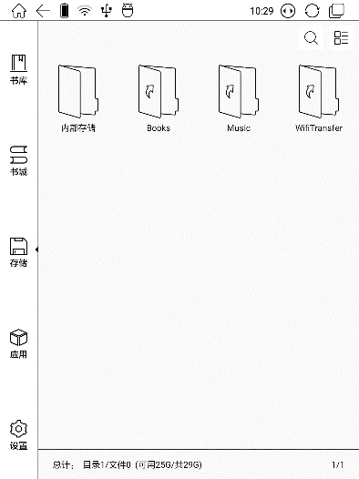

11. Apps
All installed Apps are displayed in alphabetical order A-Z by default. Users can choose their preferred order.
Long press on each APP icon to pop up the Apps menu to delete or optimize. Pre-installed applications on devices are not allowed to delete.
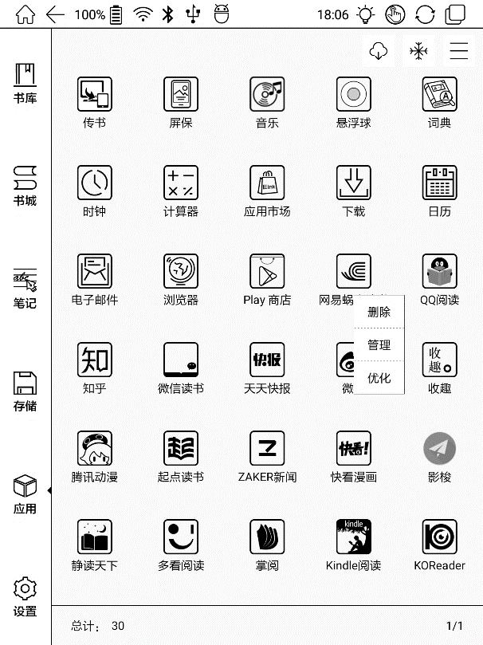

Apps Optimization
This is for screen refresh rate. Third party applications can be optimized by several settings includes dpi, contrast, color filter, refresh mode, animation filter, etc. More optimization options will be provided later.
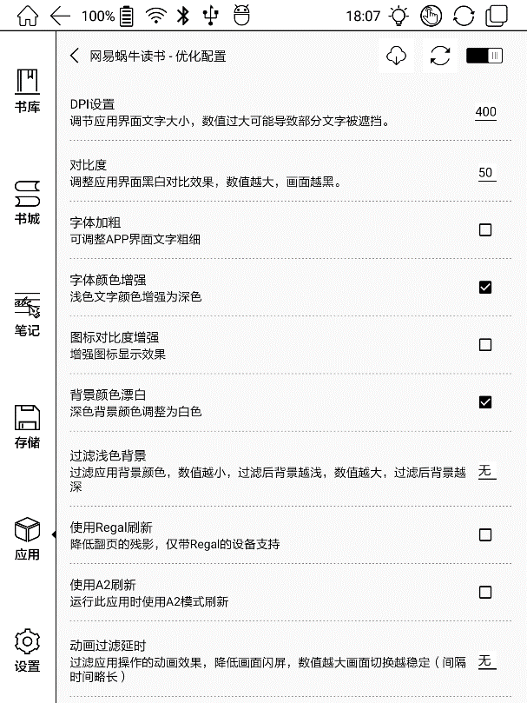

“Fetch remote optimize config” and “one key to freeze” to the third party apps helps to get a better user experience and save power.
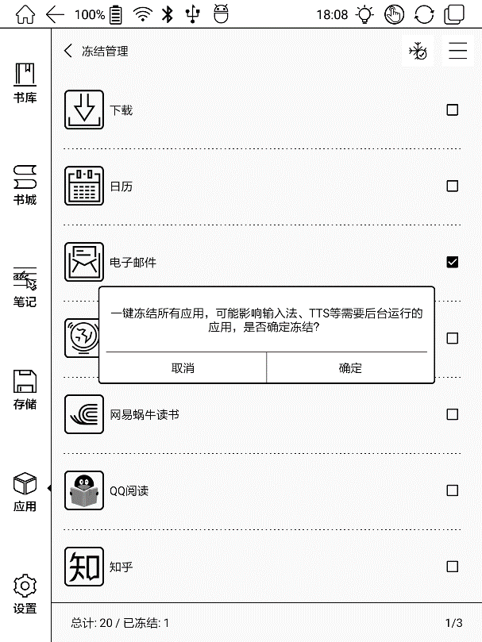

Dictionary
If users use dictionary apps the first time, to download dictionary package to local will be asked.
This function requires network connection.
Word pronunciation needs a dictionary file comes with voice files, currently TTS is not supported.
Vocabulary
生词本
Download dict
Add to vocabulary
Pronounce
Settings
Search Online

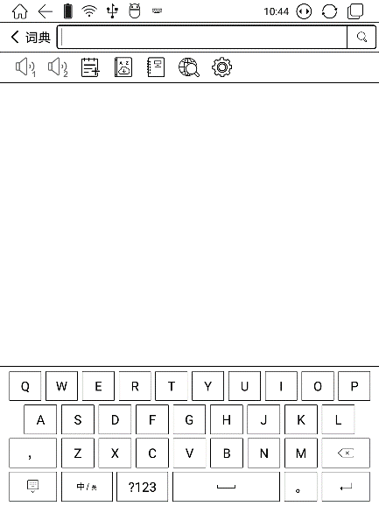

Users can install dictionaries themselves by putting the dictionary files to designated directory Storage\dicts\.
Please save the files under a folder, e.g.: dicts\English-English Dictionary.
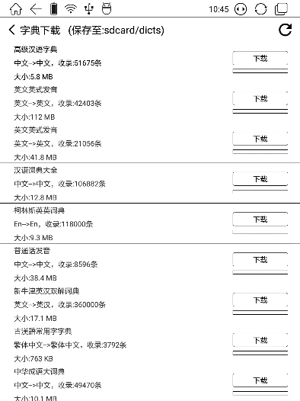

For the preferred dictionary settings, users can select up to 5 preferred dictionaries. Users will be asked to select again if the select number is less than 1 or more than 5.
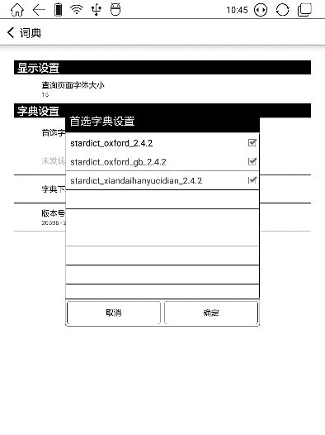

After dictionaries are installed, users can look up new words in the search bar. Switch between different dictionaries by tapping a corresponding dictionary title on the bottom.

The search result is in terms of the related dictionary. If the word is unfound, try to use other dictionaries.

Looked-up words can be added to Vocabulary.
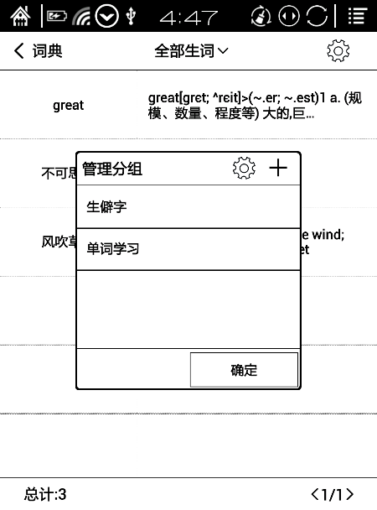
Users can divide the Vocabulary into groups. The words will be saved into the specified group once the group is selected.

WiFi Transfer
There is a way to transfer ebooks to the device--WiFi Transfer.
Please ensure that your PC or Android Phone and the device are in the uniform LAN, enter the provided IP address in a browser or scan the provided QR code to accomplish ebook transfer.
During the transfer, do not leave the page until transfer succeed. Supported formats: TXT, EPUB, PDF, MOBI, JEPG, DOC, PNG.
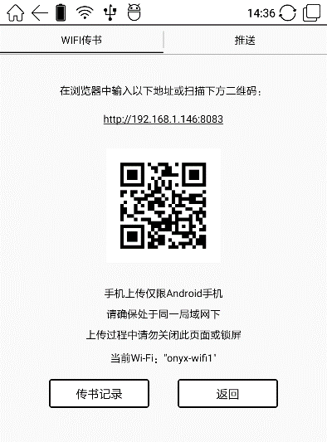

The ebooks are stored in a default path: \WifiTransfer.
Check the transfer list in“WIFI Transfer History”. You may delete the transfer history then the local files in the device would be deleted and vice versa.
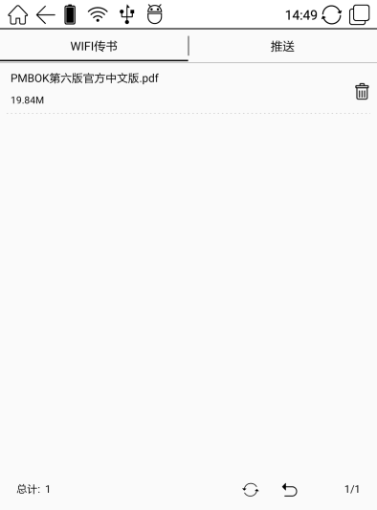

App Store (E-ink)

There are some usual third-party apps provided here. These apps are free versions from developers and their compatibility are not verified as full to the system. Paid apps download is not supported for now.
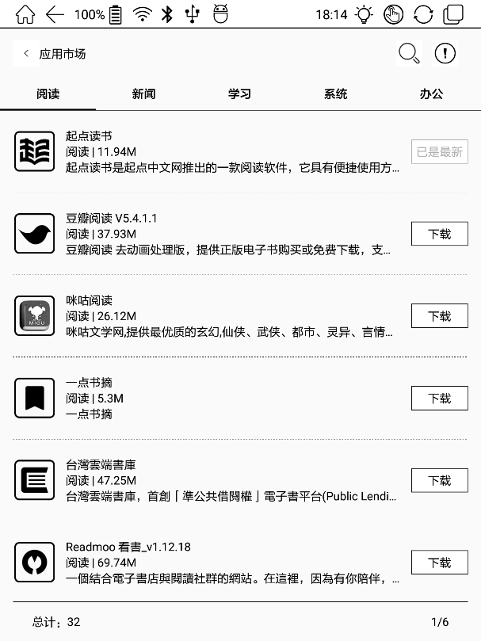

Navigation Ball
Navigation Ball is a circular ball that floats above all the apps on the screen. 5 buttons can be customized.
Single click on the ball to expand and collect navigation menu.
It requires to turn off and on again after the new button settings.
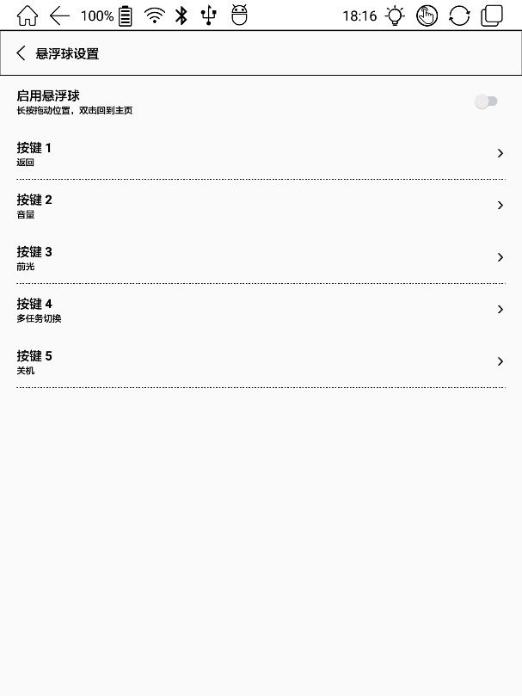

The 5 buttons can be set as multiple common functions including system operation, app switching, app optimization and so on.
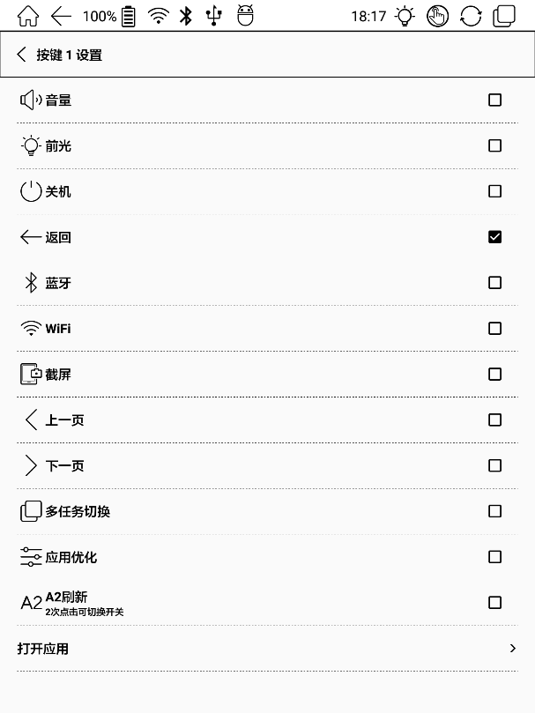

The app optimization can be called out in an app through the Navigation Ball, for real-time review after optimization (DPI setting requires app restart)
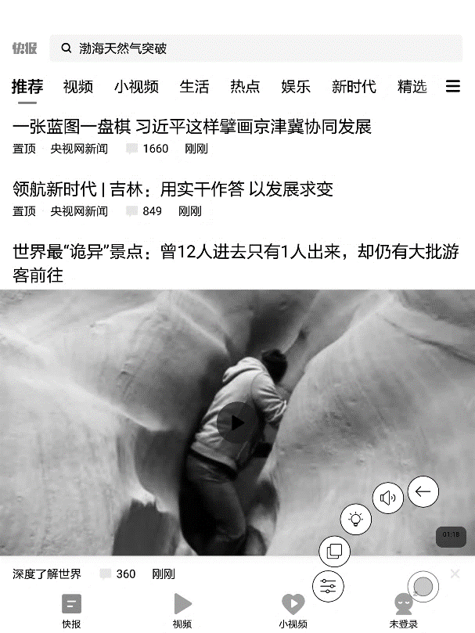

App Optimization Callout through Navigation Ball
The optimization is the same as the one by long press on app icons. The settings are synchronized.
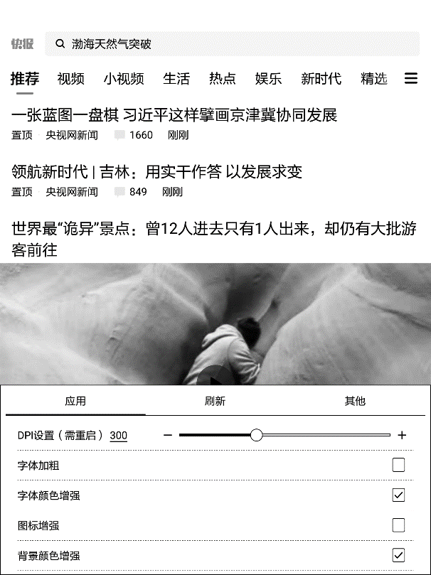

12. Settings
It contains product model, Android version, MAC address and firmware version in this page. Users can manage settings of the whole device here and click the device picture for an online user manual.
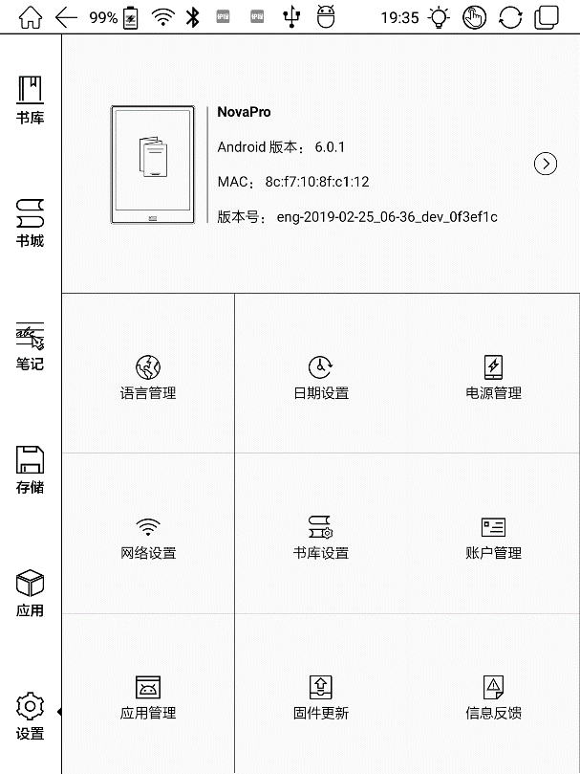

About Device
Click the model number for more information about the device, including Capacitive Touch Version, VCom, Other information, Screen Lock Password and Factory Reset.
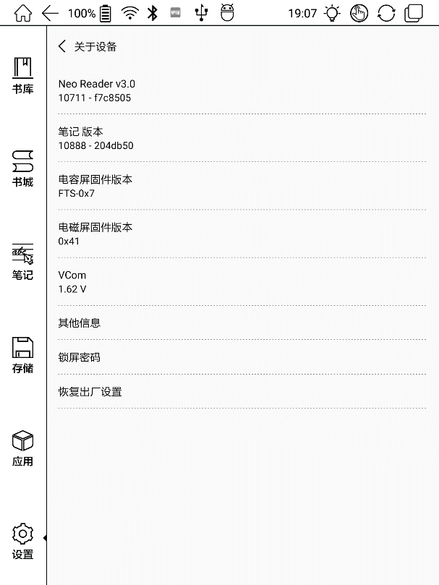

Screen Lock Password requires 4-8 digital numbers.
Temporarily no password retrieve. Please keep the password and make sure the email address is valid. In the case of losing the password, the device gets a deadlock as our company does not store any private password for users. This device needs to be cleared up and reset by sending back to the factory.
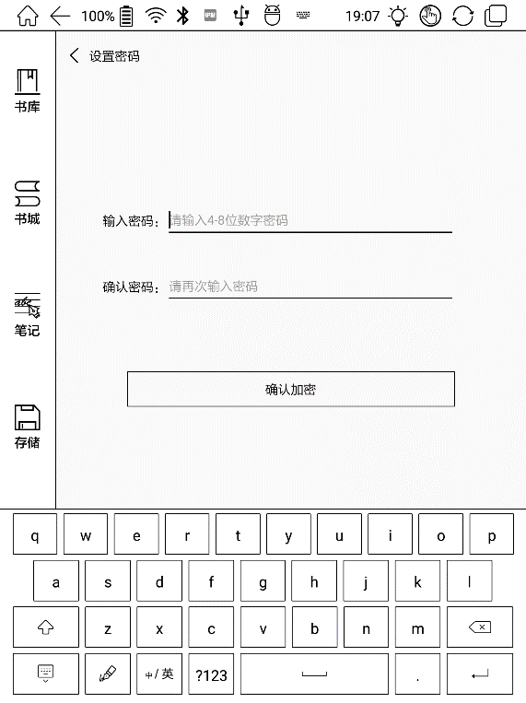
Note: To run the function of factory reset removes all of the user data. Please make a data backup.

Language setting
Users can set system language, TTS reading, dictionary and etc.
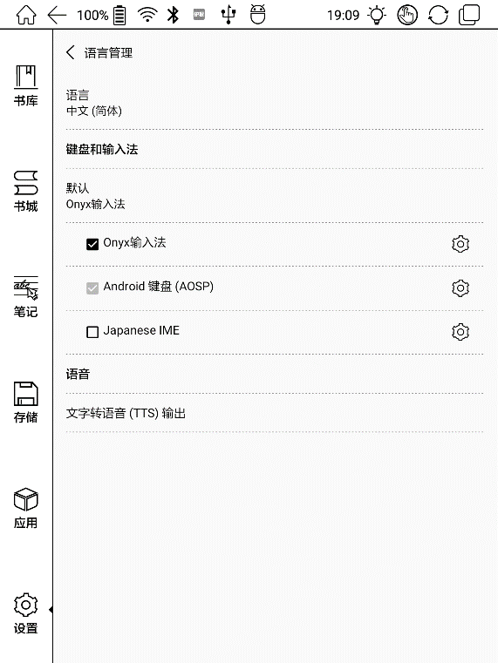
Users can set languages of the system and virtue keyboard. The system has an Android keyboard by default. Users can install third-party apps for more input methods.

ONYX Input Method
When using ONYX Input Method for the first time, users need to connect with the Internet to activate it. It could be used for Chinese and English input by default, and users need to download other language packages if they want to input other languages.
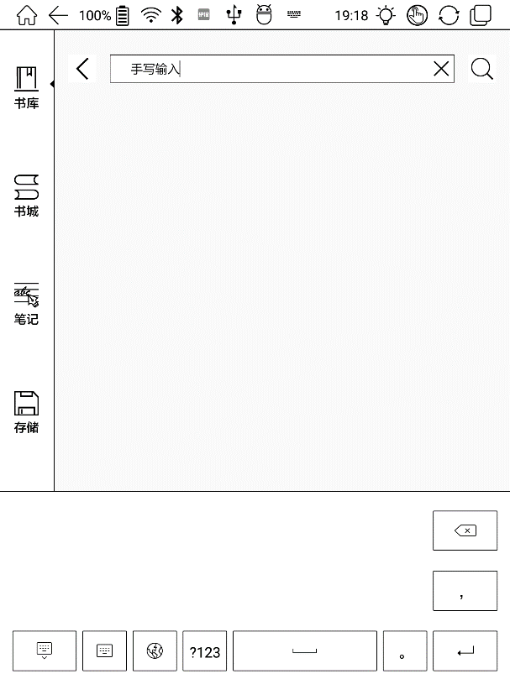

Date & Time
Users can choose either auto setting or manual setting for date and time. When the device is connected with the Internet, it will automatically set date and time according to the local time zone. Manual setting requires to set time zone, date and time.
Users can select their preferred time and date display format.

Power
Users can set screen auto sleep timeout, power off timeout, network inactivity timeout, etc.

Network
This is for Wi-Fi / VPN / Bluetooth setting.
When Wi-Fi is connected, users can browse webs and download books via the internet on the device.

WiFi Setting
When turning WiFi on, the device will search Wi-Fi hotspots automatically. When all available WLAN are listed, users can choose a network, input password to connect with the internet. WiFi signal will be displayed at “Status bar” when WiFi is connected.
After WIFI is connected successfully at the first time, the device will save WI-FI information automatically. Users only need to turn on WIFI on notification bar if using the same WIFI next time.

Bluetooth Setting
Turn on Bluetooth, you can search for nearby Bluetooth devices and send connection requests. Bluetooth needs to be paired first.
Currently it only supports the eReader to receive documents, not available to other devices.

VPN Setting
When the VPN is turned on for the first time, the system requires to set a password. This password needs to be used for screen unlock or when the factory settings are restored.

Library Setting
Users can choose to scan specified directory in storage, the default scanned files are Books, hop, Wifi Transfer and Push.
When clicking the “Scan whole storage” would scan all the files including system or app log, which may slow down the library loading speed.
Users could set the title display mode through checking the option of “show books’ titles instead of their names in library”, and books’ names are shown by default.

Account management
All accounts related data sync and push can be managed here, not including the third-party accounts.
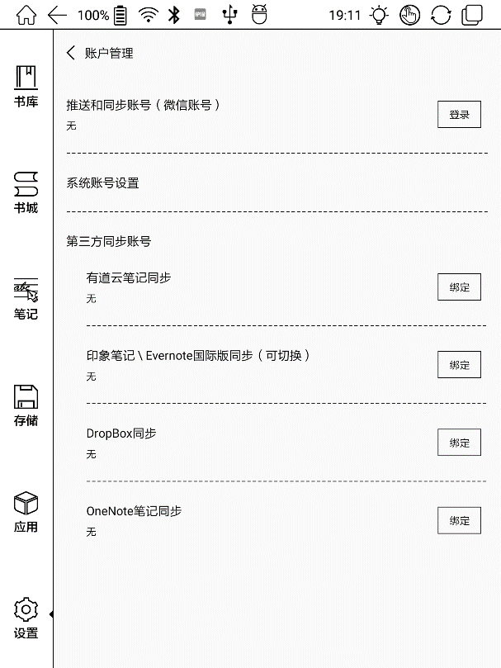

Application
Users can manage the Application setting here, such as installing unknown source Apks, USB debugging, enabling shop, auto freezing newly install applications, enabling Google Play, etc.
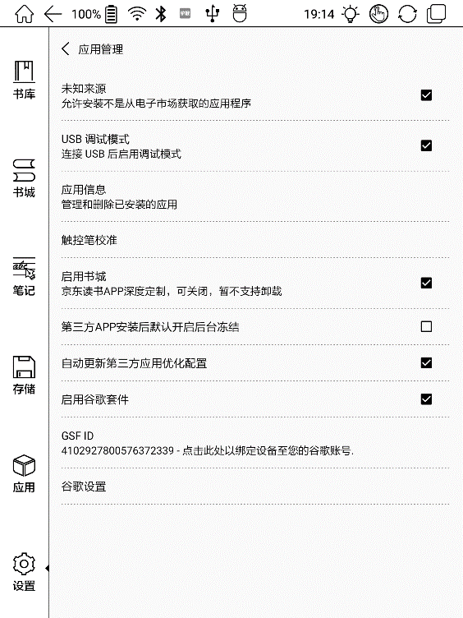
The Google Play needs to be activated for the first time. Users need to click the “Enable Google Play” and then click the GSF ID. Next users could register an account with the directions. Last users could log in again 5 to 8 minutes after registration. Users shall reboot the device and log in again if it fails.

Firmware Update
Users can get the Model number, Android version, Build number, and Automatic detection upgrade here. When choosing Check Update, it will check the local package first then online package with a network connection. Upgrade pause and breakpoint download are allowed.
Users should choose update manually since not automatically updating is set by default. Please ensure that the device has more than 15% power and sufficient capacity before the update.

Feedback
Welcome to submit any technical problem or advice to us.
This function collects system information only for problem judgment. And Onyx shall never disclose users’ device information.

13. FAQ

How to install a dictionary
The device supports dictionary formats of stardict\bgl\mdict. Users can download the dictionary packages online, and then copy to folder “Root Directory\dicts\ ”. Dictionary is available to use after that.

How to add fonts
Users can download fonts online, then copy the fonts to the folder “Storage\Fonts”, which could be created by yourself. Users can select the installed fonts when reading.

How to update
- Update locally
Download firmware update.upx from our official website. Copy the firmware to root directory of local storage. Go to Settings –Firmware Update, click the button “Check update”, and follow the instructions to update the device.
- Update by OTA
Users can update the firmware online via OTA (Setting\Firmware Update). Please connect WiFi and search for the update.upx.

How to change screen saver
Press PNG format images to pop up menu, and then click the "Set as screen saver" button.

14. Specifications

 | Nova |  | Nova Pro
Processor | Quad-core 1.6G Hz
RAM | 2G
OS | Android 6.0
Storage | 32G
Screen | E-ink display with Regal refresh
Screen Size | 7.8-inch carta screen
Resolution | 1404*1872
Touch | Capacitive touch | Capacitive touch &  electromagnetic touch
Front Light | Front Light with CTM, adjustable and closeable
Wireless | WIFI + Bluetooth
Battery | 2800 mAh
USB | Type-C
Size | 197.3x137x7.7mm
Weight | ≤240 g (battery included)
Operating Temperature | 0°C- 50°C
Book Formats | PDF, EPUB, TXT, DJVU, HTML, FB2, DOC, MOBI, CHM, etc.
Image Formats | PNG, JPG, BMP
Audio Formats | WAV , MP3
Apps | Third party APPs installation is supported
Browser | Support
Language | Multi-language supported
File Directory | Support
Dictionary | Support
TTS | Support
Refreshment Mode | A2 quickly refresh, partly refresh and fully refresh
DRM | Support
Firmware Update | Locally update and OTA update are available
Certification | CE, Rohs

Declaration
Onyx International Inc. reserves the right to modify the content of the Quick Start Guide and User Manual without further notice.
For more information, please visit our website at www.boox.com.

